XtremWeb-HEP 7.5.0
Introduction
Version 1.1.0

Table of Contents
1 Introduction 3
1.1 Audience 3
1.2 Software license agreement 3
1.3 Reading conventions 4
1.4 Middleware Versioning 4
1.5 Documentation Versioning 5
1.5.1 1.0.0 5
1.5.2 1.1.0 5
2 Introduction to XtremWeb-HEP middleware 5
3 Hardware and software requirements 8
4 Communication protocols 8
5 Object definitions 8
6 Security considerations 8
6.1 Secured communications 9
6.2 Authentication of Server, Client and Worker 9
6.3 Authorizations 10
6.4 Ownership 11
6.5 Access rights 11
6.6 Confinements 12
6.6.1 Public confinement 14
6.6.1.1 Access rights for public confinement 14
6.6.1.2 Management of a public confinement 14
6.6.1.3 Resources aggregation within a Public confinement 14
6.6.1.4 Usage of a public confinement 15
6.6.1.5 Behaviour of workers within a public confinement 15
6.6.2 Group confinement 15
6.6.2.1 Access rights for group confinement 16
6.6.2.2 Management of group confinement 16
6.6.2.3 Resources aggregation within a group confinement 16
6.6.2.4 Usage of a group confinement 17
6.6.2.5 Behaviour of worker within a group confinement 17
6.6.3 Private confinement 17
6.6.3.1 Access rights for private confinement 18
6.6.3.2 Management of a private confinement 18
6.6.3.3 Resources aggregation within a private confinement 18
6.6.3.4 Usage of a private confinement 18
6.7 Data confidentiality 19
6.8 Data integrity 19
6.9 Data persistence 19
6.10 Result certification 20
7 List of constants 21
8 Job state graph 22
9 Contacts 23
10 Index 24

Index des illustrations
Illustration 1: XtremWeb-HEP architecture 7
Illustration 2: XtremWeb-HEP Confinements View 13

Introduction

This document is part of the XtremWeb-HEP middleware documentation which contains different documents: “XtremWeb-HEP User Guide”, “XtremWeb-HEP Administrator Guide”, “XtremWeb-HEP Resource Provider Guide”, “XtremWeb-HEP Programmer Guide” and this one, “XtremWeb-HEP Introduction”.

On February 7th, 2011 :
- “XtremWeb-HEP Introduction 1.0.0” has been released
- “XtremWeb-HEP User Guide 1.1.0” has been released
- “XtremWeb-HEP Administrator Guide” is not written
- “XtremWeb-HEP Resource Provider Guide” is not written
- “XtremWeb-HEP Programmer Guide” is not written

Audience

Anyone who would like to administrate or use the XtremWeb-HEP middleware should read this document.

This document specifically introduces the client component of the XtremWeb-HEP middleware and details user interactions: how to insert datas, applications; how to submit jobs and retrieve results etc.

With this document, as user of the XtremWeb-HEP middleware, the reader will be able to use the distributed resources managed by an XtremWeb-HEP infrastructure.

Software license agreement

XtremWeb-HEP is an open source software provided under the GPL2 license (http://www.gnu.org/licenses/gpl-2.0.html).

BECAUSE THE PROGRAM IS LICENSED FREE OF CHARGE, THERE IS NO WARRANTY FOR THE PROGRAM, TO THE EXTENT PERMITTED BY APPLICABLE LAW. EXCEPT WHEN OTHERWISE STATED IN WRITING THE COPYRIGHT HOLDERS AND/OR OTHER PARTIES PROVIDE THE PROGRAM "AS IS" WITHOUT WARRANTY OF ANY KIND, EITHER EXPRESSED OR IMPLIED, INCLUDING, BUT NOT LIMITED TO, THE IMPLIED WARRANTIES OF MERCHANTABILITY AND FITNESS FOR A PARTICULAR PURPOSE. THE ENTIRE RISK AS TO THE QUALITY AND PERFORMANCE OF THE PROGRAM IS WITH YOU. SHOULD THE PROGRAM PROVE DEFECTIVE, YOU ASSUME THE COST OF ALL NECESSARY SERVICING, REPAIR OR CORRECTION.

IN NO EVENT UNLESS REQUIRED BY APPLICABLE LAW OR AGREED TO IN WRITING WILL ANY COPYRIGHT HOLDER, OR ANY OTHER PARTY WHO MAY MODIFY AND/OR REDISTRIBUTE THE PROGRAM AS PERMITTED ABOVE, BE LIABLE TO YOU FOR DAMAGES, INCLUDING ANY GENERAL, SPECIAL, INCIDENTAL OR CONSEQUENTIAL DAMAGES ARISING OUT OF THE USE OR INABILITY TO USE THE PROGRAM (INCLUDING BUT NOT LIMITED TO LOSS OF DATA OR DATA BEING RENDERED INACCURATE OR LOSSES SUSTAINED BY YOU OR THIRD PARTIES OR A FAILURE OF THE PROGRAM TO OPERATE WITH ANY OTHER PROGRAMS), EVEN IF SUCH HOLDER OR OTHER PARTY HAS BEEN ADVISED OF THE POSSIBILITY OF SUCH DAMAGES.

Reading conventions

Code examples appear in grey boxes
$> ./proxy-init.sh desktopgrid.vo.edges-grid.eu
Enter your private key passphrase:
Created VOMS proxy: O=GRID-FR,C=FR,O=CNRS,OU=LAL,CN=Oleg Lodygensky,CN=proxy
Proxy is valid until: Fri Nov 19 21:59:37 2010 CET
Proxy location: /var/folders/0R/0RQqVNNAEpqqeXUidaIL0++++TM/-Tmp-/x509up_u_mboleg

Variables appear in courier font, within '${' and '}', just as “${VARIABLE}”. They should be understood and replaced by their values.

Some variables used in this document:
${XWHEP_VERSION} is the current version of our middleware
${XWHEP_HOME} is the directory where the middleware is installed
${HOME} is the user home directory

Sometimes there are some inputs the reader must provide. These appear in courier font, within '<' and '>', just as “<your input>”.

Middleware Versioning

Middleware versioning is as follow
- X is the major part of the version
- Y is the minor part of the version
- Z is the micro part of the version

(*) X reports a very important change : for example the communication protocol changes or a major new feature is modified/introduced/removed
When X changes, backward compatibility is not ensured

(*) Y reports a important but not critical change : backward compatibility is ensured

(*) Z reports a minor change : bug correction, documentation changes etc.

In April 2011, the last version of XtremWeb-HEP is 7.4.1.
In this document we refer that version as the current version and refer it as ${XWHEP_VERSION}.

Documentation Versioning

Documentation versioning is as follow
- X is the major part of the version
- Y is the minor part of the version
- Z is the micro part of the version

1.0.0

Date : May 5th , 2011
Authors : O. Lodygensky
Reviewers :

Initial document.

1.1.0

Date : May 25th, 2011
Authors : O. Lodygensky
Reviewers :

- XWHEP 7.5.0 introduces full certificate usage

Introduction to XtremWeb-HEP middleware

XtremWeb-HEP (XWHEP) is a middleware permitting to deploy a distributed data processing infrastructure (computing grid). XWHEP belongs to the so called Cycle Stealing family that uses idle resources. Like some other grid middleware stacks, XWHEP uses remote resources (PCs, workstations, PDA, servers) connected to Internet, or a pool of resources inside a LAN. Participants of an XWHEP infrastructure cooperate by providing their computing resources, such as processor, memory and/or disk space.
XWHEP is a lightweight grid middleware. Its a Free Software (GPL), Open Source and non-profit software to explore scientific issues and applications of Global Computing and Peer to Peer distributed systems.
The XWHEP middleware allows to setup and run Distributed Systems. Such project infrastructure be based on a community of participants. For example, XtremWeb-HEP allows a High School, a University or a Company to setup and run a Global Computing or Peer to Peer distributed system for either a specific application or a range of applications.

The middleware is written in Java 1.6 computing language.

Architecture
The XWHEP architecture contains three parts, as shown in figure 1:
- one or a group of several Servers is installed and maintained by system administrators to host centralized XWHEP Services such as the 'Scheduler' and the 'Result Collector';
- distributed parts deployed over the internet:
  - XWHEP Workers are installed by citizens on their PCs to propose their computing resources to be aggregated within an XWHEP infrastrucutre;
  - XWHEP Clients are installed by XWHEP users (scientists, for example) on their PCs to interact with the infrastructure. The XWHEP client permits users to manage the platform as well as to use distributed resources (submit jobs, retrieve results...).

This architecture corresponds to most of well known Global Computing Projects:
- The XWHEP central services permit the XWHEP administrator to manage registered applications.
- A client prepares data that are needed to successfully compute jobs. These data may be stored in the XWHEP infrastructure or in any repository as soon as the data can be described by an URI and are accessible through the network. There is no limit on data size, but it is assumed that data should not exceed a few hundred mega-bytes.
- A Client registers applications on the XWHEP infrastructure.
- A Client prepares jobs (units of work) containing the reference of a registered application, optional parameters, optional references to additional files.
- Finally, a Client submits jobs to the XWHEP Scheduler.
- The Workers contact a Scheduler to get jobs suitable for their architecture.
- In response, the Scheduler sends a suitable job description to a Worker.
- For each file referenced by the job which is not present in the local cache of the Worker yet, the Worker fetches the file from the XWHEP Data Repository or from an External Data Server.
- As soon as a job has finished on Worker side, the Worker contacts the Result Collector to send the results.

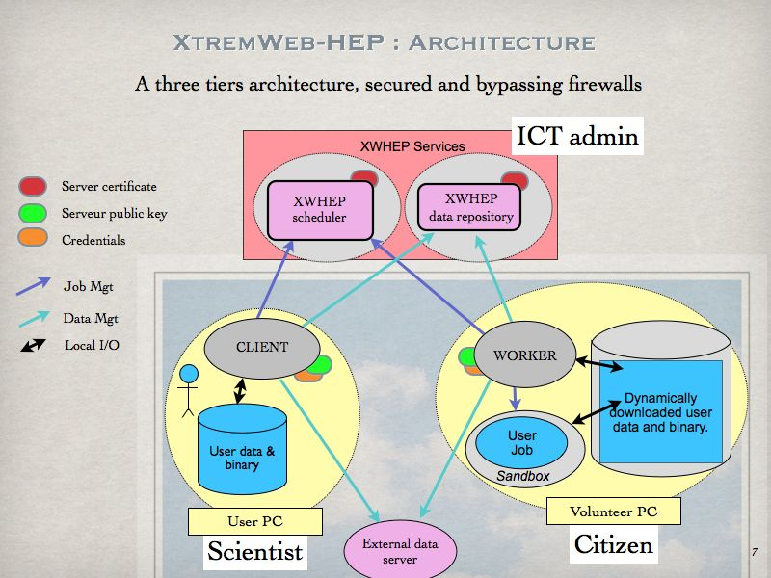
Illustration 1: XtremWeb-HEP architecture

Hardware and software requirements

The XtremWeb-HEP middleware is written in Java 1.6 computing language.

To run any component of the middleware you need:
- a machine running Windows, or Linux or Mac OS X
- java runtime environment 1.6 or above

Communication protocols

Since the platform is distributed, communications are a key point of the XWHEP middleware. The XWHEP middleware tends to be communication protocol agnostic by allowing different low level protocol as well as several high level ones. Developers may implement their own protocols by extending CommServer and CommClient abstract classes. (Please refer to the “XtremWeb Programmer Guide”). The middleware designs low level protocols as “communication layer” and high level ones as “communication handlers”.

The XWHEP middleware provides two communication layers : UDP and TCP, as well as three communication handlers described by their URI scheme: HTTP, ATTIC and the XWHEP middleware own one: XW.
That last has been introduced to follow the desktop grid requirements and implements a high level of security (see chapter 6).

Object definitions

Please refer to the “XtremWeb-HEP Programmer Guide”.

Security considerations

The middleware ensures security at different levels. In this chapter we detail security in the client-server interaction. Security services and protocols in this context can be introduced as follows :

- Secured communications
- Authentication of Server, Client and Worker
- Authorizations
- Access rights
- Confinements
- Data confidentiality
- Data integrity
- Data persistence
- Result certification

Secured communications

As sensitive data may be transferred in the network, the XtremWeb-HEP middleware systematically ensures communications privacy by using TLS encryption. This ensures confidentiality by using encryption and by identifying communicating entities.

Authentication of Server, Client and Worker

Server authentication is implemented by the usage of an electronic key pair: the server private key (shown in red in figure 1) is securely stored on server side, and the server public key (shown in green in figure 1) is enclosed inside the installation packages of the client and worker.
This permits to certify the server identity: distributed XtremWeb-HEP components establish a session with a Server only if this server proves that it owns the private key corresponding to the public key.
On the other side, the server doesn't accept connection without receiving its own public key.

Being connected to the server is not sufficient to execute a command on server side. Each Client must present valid credentials so that the server can securely identify who is connecting.
In XtremWeb-HEP, two credential types are accepted by the server :
- login/password
- X509 certificate

Using login/password
Login/password is a key pair that uniquely defines an identity. Such identities must be inserted by the XtremWeb-HEP administrator.
It is the administrator responsibility to securely send login/password pair to whom it may concern.

Using X509 certificate
The XtremWeb-HEP middleware is able to use X509 certificates. This is an IETF standard ensuring certificate owner identity. It is out of scope to detail certificate in this document.
The middleware authenticates communication initiator presenting an X509 certificate by verifying the certificate authority (CA) that signed the certificate.

It is the XtremWeb-HEP administrator responsibility to manage its list of known CA certificates.

The authentication process, if successful, defines an identity. This identity is used on server side to execute commands sent by the distributed component (client, worker). An identity has several attributes: first name, last name, email etc.
An identity has also some critical attributes involved in security: credentials (login and password, or X509 certificate), user group membership and authorization.

The XtremWeb-HEP middleware manages user groups. Any user may belong to a user group. User groups aim to confine accesses so that members of the group are allowed to access objects defined within the group. These objects confined in a group are not accessible by users who don't belong to the user group.

Authorizations

Being authenticated by the server is not sufficient to execute a command on server side. Each authenticated entity has a usage level called “user rights”, that defines authorization.
Authorization allows or denies execution of requested action.

Authorizations are defined as enumerations from least to most privileged. Please refer to the “XtremWeb-HEP Programmer's Guide”.
The super_user authorization allows all access rights on all XtremWeb-HEP objects.. In the XtremWeb-HEP middleware, we call “administrator” an entity associated to a super_user authorization.
The standard_user authorization allows to do actions such as insert_job, insert_data etc.

The general case is as follow: user rights R allow to perform an action A if and only if :
0 < A <= R

The only one specific case is: worker_user. Presenting an identity associated with this user rights, one can :
- never list anything (list_app, list_data etc.)
- never insert anything (insert_app, insert_data etc.)
- never delete anything (delete_app, delete_data etc.)
- ask for a pending job
- send a heartbeat signal
- retrieve an application by providing the application unique identifier (UID)
- download data
- upload result for the job it has computed (this is checked by the server)

Ownership

In XtremWeb-HEP, each object has an owner. By default, the owner has full access to his/her objects.
Any user may have access to an object he/she does not own, if this object permits it.
For example, any user belonging to a user group may have access to an object owned by a member of the same user group, if this object permits group access.

Accesses are defined by object access rights presented in next chapter.

Access rights

Being allowed to execute a command on server is not sufficient to execute this command on an object managed by the server.
All object (applications, data, jobs etc.) are associated to access rights. This has been implemented “a la” linux file system access rights. Access rights allow or deny access to the objet it is associated with.
XtremWeb-HEP assigns Read, Write and Execute access rights separately for the owner of the object, for members of the group the owner belongs to (if any), and for others.

Access rights of an object can by modified by its owner or by an XtremWeb-HEP administrator.
But it is never possible to increase access rights, except for administrator.

There is one exception where access rights are fully bypassed so that access is always allowed: an XtremWeb-HEP administrator is always allowed to access (read, write, execute) any object. This exception permits to modify access rights in any manner (even increasing).

Access rights are defined like this :

U_{R} U_{W} U_{E} G_{R} G_{W} G_{E} O_{R} O_{W} O_{E}

Where

U_{R} = User (owner) read access rights
U_{W} = User (owner) write access rights
U_{E} = User (owner) execute access rights, if applicable
G_{R} = Group read access rights
G_{W} = Group write access rights
G_{E} = Group execute access rights, if applicable
O_{R} = Other read access rightss
O_{W} = Other write access rights
O_{E} = Other execute access rights, if applicable

Examples in octal notation:

755 defines
- full accesses for the owner;
- read and execute accesses to the owner group, if any;
- read and execute accesses to others.

750 defines
- full accesses for the owner;
- read and execute accesses to the owner group, if any;
- no access to others.

700 defines
- full accesses for the owner;
- no access to the owner group, if any;
- no access to others.

Confinements

Since XtremWeb-HEP assigns an authorisation to each identity and access rights to each object, XtremWeb-HEP effectively confines all objects it manages. Inside XtremWeb-HEP, a combined setup of authorisations and access rights is call a confinement.

All applications, all data, all jobs are confined. But also all users, all clients and all workers.

Confinements aim to restrict accesses so that distributed entities (clients and workers) are allowed or denied to access (read, write, execute) confined objects.
The XtremWeb-HEP middleware helps to define as many confinements as possible combinations of authorizations and access rights.

In this chapter, we present the three major confinements:
- public
- group
- private

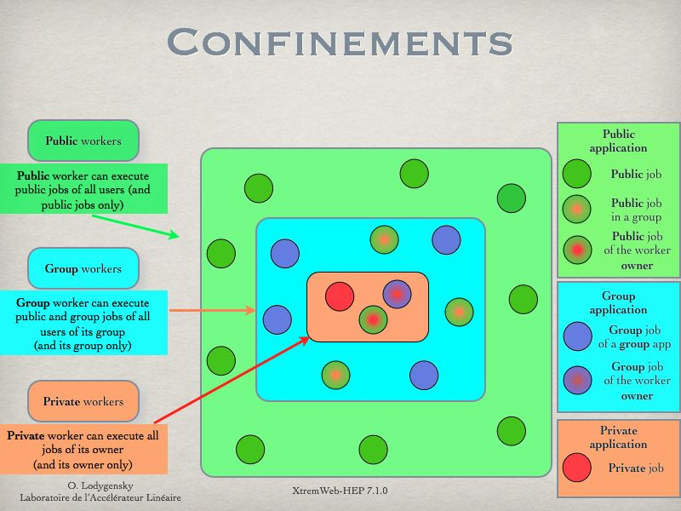
Illustration 2: XtremWeb-HEP Confinements View
Confinement paradigms are shown in figure 2 representing the three majors confinement levels : public, group and private.
Following sub chapters detail these confinements.

Public confinement

This is the default confinement. It is shown in green in figure 2. In a public confinement, everything is public, all distributed entities (workers, clients) have read and execute accesses to public objects. The write access, if set, is reserved to the owner only.
A public confinement is made of public objects:
- public applications;
- public jobs;
- public data;
- public workers;
- public clients;
- public users.

Access rights for public confinement

Public access rights are defined to allow owner full accesses, group read and execute accesses as well as read and execute accesses to others.
The octal value of the public access rights is : 755.

Management of a public confinement

The XtremWeb-HEP administrator is the only user allowed to manage a public confinement. Administrator authorization is the only one that permits to insert, delete and modify public users, public workers and public applications.

Resources aggregation within a Public confinement

The XtremWeb-HEP administrator is the only user allowed to perform resource aggregation in a public confinement. To do so, the administrator must create an identity associated with worker_user authorization.
This identity must not belong to any user group.

It is then the administrator responsibility to prepare worker installation packages that will install worker with this identity. All deployed workers will then connect to the server and present this identity.
Such workers will be automatically public.
There is no way to modify this.
Public workers execute public jobs only.

Usage of a public confinement

Any user can read and execute public objects.
Users who don't have administrator authorization can not modify public objects they don't own.
Users can send public data.
Users can submit jobs referring public applications.

Public applications must refer public data only.
Jobs referring public application are automatically public.
There is no way to modify this.
Public jobs must also refer public data only.

Behaviour of workers within a public confinement

All workers are allowed to access all public objects.

Worker confinement depends on the identity a worker presents when it connects to the XtremWeb-HEP server. A worker is public if this identity is associated with worker_user authorization and does not belong to any user group.
Public workers are not allowed to access non public objects (group and private objects).
This is why jobs referring public application are automatically public and must refer public data only.

Group confinement

This confinement confines accesses within a group of users only. By default all entities defined within a user group have read and execute accesses to group objects.
A group confinement is made of group objects:
- group applications;
- group jobs;
- group data;
- group workers;
- group clients;
- group users.

Access rights for group confinement

Group access rights are defined to allow owner full accesses, group read and execute accesses and to deny accesses to others.
The octal value of the group access rights is : 750.

Management of group confinement

The XtremWeb-HEP administrator is the only user allowed to create a group confinement. The administrator should delegate group management to a group administrator. A group administrator is an identity defined in a user group and associated to advanced_user authorization.
A group administrator is allowed to insert, delete and modify group objects (users, workers , applications....).

Resources aggregation within a group confinement

The group administrator is allowed to manage resources aggregation in a group confinement. To do so the group administrator must create an identity within its group and associated with worker_user authorization.
It is then the group administrator responsibility to prepare worker installation packages that will install a group worker with this identity. All deployed workers will then connect to the server and present this identity.

Such workers will be automatically group workers.
There is no way to modify this.
Group workers can execute any public jobs.
Group workers may also be restricted to execute public jobs owned by members of its group.
Group workers can execute group jobs owned by members of its group.
(this includes group and public jobs)

Usage of a group confinement

Any member of the group can read and execute group objects. Others can't.
Users who are not administrator of the group can not modify group objects they don't own.
Users can send group data.
Users can submit jobs referring group applications.

Group applications must refer public data or data of its group only.
Jobs referring group application are automatically group jobs.
There is no way to modify this.
Group jobs may refer any public data and data of the group.

Behaviour of worker within a group confinement

All workers are not allowed to access group objects.

Worker confinement depends on the identity a worker presents when it connects to the XtremWeb-HEP server. A worker is a group worker if this identity is associated with worker_user authorization and belongs to a user group.
Group workers are allowed to access public objects and objects defined in the group.
Group workers are not allowed to access private objects or objects defined in other groups.
This is why jobs referring group application are automatically group jobs and must refer data accessible within the group (public data and data defined in the group).

Private confinement

This confinement confines accesses to a single user only. All entities defined as private deny accesses to all users but the owner.
A private confinement is made of private objects:
- private applications;
- private jobs;
- private data;
- private workers.

Access rights for private confinement

Private access rights are defined to allow owner full accesses and to deny accesses to all others.
The octal value of the private access rights is: 700.

Management of a private confinement

Any user can manage its own private confinement.

Resources aggregation within a private confinement

Any user is allowed to manage its own private resource aggregation.
A resource is private when its presents owner credentials not associated to worker_user authorization (belonging or not belonging to any user group).
It is then the user responsibility to prepare worker installation packages that will install a private worker with its own identity. All deployed workers will then connect to the server and present this identity.
Such workers will be automatically private workers.
There is no way to modify this.
Private workers execute jobs owned by its owner only.
(this includes private and group and public jobs)

Usage of a private confinement

The owner is the only user allowed to access his/her private objects.
Users can send private data.
Users can submit jobs referring private applications.

Private applications must refer data accessible by the application owner.
Jobs referring private application are automatically private jobs.
There is no way to modify this.
Private jobs may refer any data accessible by its owner.

Data confidentiality

Data may circulate over the network, from client to server, from server to workers, and back. Communication are secured as described in chapter 6.1 .

The middleware enforces data confidentiality according to the authorization and access rights mechanisms described above. The confinement ensures that :
- private objects are sent to private clients and workers only;
- group objects are sent to group clients and workers only;
- public objects are freely accessible.

XtremWeb-HEP provides absolutely no guarantee as soon as an object is sent to a distributed entity.

It is the user responsibility to properly use confinement mechanisms to ensure confidentiality and restricted access to sensitive data.
X509 certificates are automatically private data. This ensures that this very sensitive data will never be downloaded by any one, but the owner. The middleware is written in such a way that workers can never access certificates.

Data integrity

The middleware ensures data integrity by checking data size and MD5 checksum on each access. It is the XtremWeb-HEP administrator responsibility to ensure integrity of data stored on server side.

Data persistence

The XtremWeb-HEP middleware does not propose anything on this field.

It is the end user responsibility to ensure persistence of his/her data. For example by using BitDiew P2P storage or EGI Storage Elements.
The administrator may remove any data from the server without any formal notification to the data owner.
It is the administrator responsibility to ensure it does not remove any data that may lead to some problems regarding registered applications and submitted jobs.

Result certification

The XtremWeb-HEP middleware does not propose anything on this field.

It is the end user responsibility to verify the results of his/her jobs.

List of constants

Please refer to the “XtremWeb Programmer's Guide”.

Job state graph

Please refer to the “XtremWeb-HEP Programmer's Guide”.

Contacts

If you need help contact XWHEP team : xtremweb (at) lal.in2p3.fr

The XWHEP website : http://www.xtremweb-hep.org

You can find RPM and Mac OS X packages at this address :
http://www.xtremweb-hep.org/spip.php?article52

Membership request to VO :
https://grid12.lal.in2p3.fr:8443/voms/vo.lal.in2p3.fr/Siblings.do

jLite library :
http://code.google.com/p/jlite/

Index
Index lexical
Client 6
HOME 4
login 9
MD5 checksum 19
password 9
Result Collector 6
Scheduler 6
TLS 9
Worker 6
X509 certificate 9, 10
XWHEP_HOME 4
XWHEP_VERSION 4

To reduce bandwidth usage, the worker manages a local cache in least recently used (LRU) mode. Each time the computer is restarted, the worker automatically cleans this local cache. This ensures that the worker does not use to much local disk space, but the worker may then sometimes need to download the same file from run to run.
http://www.atticfs.org/
“write” includes “modify” and “delete”.
http://www.bitdew.net/

