XtremWeb-HEP 8.0.0
“FlyingGrid”
Extended Introduction
Version 1.1.0

Table of Contents
1 Introduction 3
1.1 Audience 3
1.2 Software license agreement 3
1.3 Reading conventions 4
1.4 Middleware Versioning 4
1.5 Documentation Versioning 5
1.5.1 Version 1.0.0 5
1.5.2 Version 1.0.1 5
1.5.3 Version 1.1.0 5
2 Introduction to XtremWeb-HEP middleware 6
3 Extensions of the XtremWeb-HEP middleware 6
3.1 Volunteer sharing 6
3.1.1 Shared application 7
3.1.2 Shared library 8
3.1.3 Shared data 8
3.2 Inter node communication 8
3.2.1 Security consideration 10
4 Virtualization over desktop grid 11
4.1 Introduction 11
4.2 Security considerations 11
4.2.1 Background 11
4.2.2 User rights 12
4.2.3 Connection security 12
4.2.4 Network access 12
4.3 Virtual machines over desktop grid 13
4.3.1 Installation 13
4.3.2 Registering shared application 13
4.3.3 Proposing shared application 14
4.3.4 Submitting a virtual machine 14
4.4 Contextualization 15
4.4.1 Introduction to contextualization 15
4.4.2 Contextualization structure 16
4.4.3 Create a new contextualization disk 17
4.5 Virtual machines provision 17
5 Contacts 18
6 Third party libraries 18
7 Index 19

Index des illustrations
Figure 1: Volunteer sharing 7
Figure 2: Internode communications 9
Figure 3 : LiveCD customization 16

Introduction

This document is part of the XtremWeb-HEP (XWHEP) middleware extended documentation which contains different documents: “XtremWeb-HEP Extended Programmer Guide”, “XtremWeb-HEP Extended Administrator Guide”, “XtremWeb-HEP Extended Resource Provider Guide”, “XtremWeb-HEP Extended User Guide”, “XtremWeb-HEP Virtual Machines” and this one, “XtremWeb-HEP Extended Introduction”.

This extended documentation extends the standard one by detailing new features, new protocols, new services and new paradigms introduced in XtremWeb-HEP 8 designated as “FlyingGrid ”.

Please note that the documentation versioning is different from the middleware one.

On February 18th, 2012 :
- “XtremWeb-HEP Extended Introduction 1.1.0” is written;
- “XtremWeb-HEP Extended Programmer Guide 1.0.0” is written;
- “XtremWeb-HEP Extended User Guide 1.0.0” is written;
- “XtremWeb-HEP Extended Administrator Guide 1.0.0” is written;
- “XtremWeb-HEP Extended Resource Provider Guide 1.0.0” is written;
- “XtremWeb-HEP Virtual Machines 1.0.0” is written.

Audience

Anyone who would like to administrate or use the XtremWeb-HEP middleware should read this document.

This document specifically introduces the XtremWeb-HEP middleware, its services and protocols.

Software license agreement

XtremWeb-HEP is an open source software provided under the GPL2 license (http://www.gnu.org/licenses/gpl-2.0.html).

BECAUSE THE PROGRAM IS LICENSED FREE OF CHARGE, THERE IS NO WARRANTY FOR THE PROGRAM, TO THE EXTENT PERMITTED BY APPLICABLE LAW. EXCEPT WHEN OTHERWISE STATED IN WRITING THE COPYRIGHT HOLDERS AND/OR OTHER PARTIES PROVIDE THE PROGRAM "AS IS" WITHOUT WARRANTY OF ANY KIND, EITHER EXPRESSED OR IMPLIED, INCLUDING, BUT NOT LIMITED TO, THE IMPLIED WARRANTIES OF MERCHANTABILITY AND FITNESS FOR A PARTICULAR PURPOSE. THE ENTIRE RISK AS TO THE QUALITY AND PERFORMANCE OF THE PROGRAM IS WITH YOU. SHOULD THE PROGRAM PROVE DEFECTIVE, YOU ASSUME THE COST OF ALL NECESSARY SERVICING, REPAIR OR CORRECTION.

IN NO EVENT UNLESS REQUIRED BY APPLICABLE LAW OR AGREED TO IN WRITING WILL ANY COPYRIGHT HOLDER, OR ANY OTHER PARTY WHO MAY MODIFY AND/OR REDISTRIBUTE THE PROGRAM AS PERMITTED ABOVE, BE LIABLE TO YOU FOR DAMAGES, INCLUDING ANY GENERAL, SPECIAL, INCIDENTAL OR CONSEQUENTIAL DAMAGES ARISING OUT OF THE USE OR INABILITY TO USE THE PROGRAM (INCLUDING BUT NOT LIMITED TO LOSS OF DATA OR DATA BEING RENDERED INACCURATE OR LOSSES SUSTAINED BY YOU OR THIRD PARTIES OR A FAILURE OF THE PROGRAM TO OPERATE WITH ANY OTHER PROGRAMS), EVEN IF SUCH HOLDER OR OTHER PARTY HAS BEEN ADVISED OF THE POSSIBILITY OF SUCH DAMAGES.

Reading conventions

Code examples appear in grey boxes
$> ./proxy-init.sh desktopgrid.vo.edges-grid.eu
Enter your private key passphrase:
Created VOMS proxy: O=GRID-FR,C=FR,O=CNRS,OU=LAL,CN=Oleg Lodygensky,CN=proxy
Proxy is valid until: Fri Nov 19 21:59:37 2010 CET
Proxy location: /var/folders/0R/0RQqVNNAEpqqeXUidaIL0++++TM/-Tmp-/x509up_u_mboleg

Variables appear in courier font, within '${' and '}', just as “${VARIABLE}”. They should be understood and replaced by their values.

Some variables used in this document:
${XWHEP_VERSION} is the current version of our middleware
${XWHEP_HOME} is the directory where the middleware is installed
${HOME} is the user home directory

Sometimes there are some inputs the reader must provide. These appear in courier font, within '<' and '>', just as “<your input>”.

Middleware Versioning

Middleware versioning is as follow
- X is the major part of the version
- Y is the minor part of the version
- Z is the micro part of the version

(*) X reports a very important change : for example the communication protocol changes or a major new feature is modified/introduced/removed
When X changes, backward compatibility is not ensured

(*) Y reports a important but not critical change : backward compatibility is ensured

(*) Z reports a minor change : bug correction, documentation changes etc.

In September 2011, the last version of XtremWeb-HEP is 8.0.0.
In this document we refer that version as the current version and refer it as ${XWHEP_VERSION}.

Documentation Versioning

Documentation versioning is as follow
- X is the major part of the version
- Y is the minor part of the version
- Z is the micro part of the version

Version 1.0.0

Date : Sept , 2011
Authors : O. Lodygensky
Reviewers :

Initial document introducing XWHEP 8 “FlyingGrid”.

Version 1.0.1

Date : Dec , 2011
Authors : O. Lodygensky
Reviewers :

Merging former “xwhep-vm.odt” document in this one.

Version 1.1.0

Date : January, 2012
Authors : O. Lodygensky
Reviewers :

Use cases and examples moved to the extended user guide.

Introduction to XtremWeb-HEP middleware

The XtremWeb-HEP middleware is introduced in the “XtremWeb-HEP Introduction” document from the standard documentation. The reader is invited to refer to that document.

This document presents extensions of the middleware introduced since XtremWeb-HEP 8.

The reader is invited to first read the “XtremWeb-HEP Introduction” prior to read this document.

Extensions of the XtremWeb-HEP middleware

This version introduces:
- volunteer sharing;
- inter node communication.

Volunteer sharing

This new version of the XtremWeb-HEP middleware, XWHEP 8 designated as“FlyingGrid”, adds the new “volunteer sharings” paradigm. This new version keeps all previous functionalities and introduces new paradigms, services and protocols to implement the “volunteer sharing” paradigm.
The architecture remains the same. Desktop grids intend to aggregate distributed volunteer computing resources (known as “worker” in XWHEP) and distribute tasks on demand. According to a local activation policy, the worker connects to the centralized server, downloads task (binary code and their associated data) and executes the downloaded binary code. This mode is known as the “pool” mode.
By introducing the “volunteer sharing” paradigm, the worker still work following the pool mode mechanism but can also propose some objects to share: data, applications and library.
This shared objects must still be registered on server side. But objects registered as voluntary sharing are not downloaded by the worker since that last are supposed to have a local copy. A volunteer sharing will never be downloaded. This clearly means that volunteer resources which do not have this object will never be asked to use it. For example if the shared object is an application, volunteer resources which have this application installed could be selected to compute jobs referring this application; but volunteer resources which do not have this application installed -and/or do not declare it as a sharing- will never be selected to run jobs referring this application.
One must note that all security paradigms introduced in previous versions are still applied, even to shared objects: authentication, authorization, confinement, logging and bookkeeping, as well as access rights. They all apply to shared object since that last must still be registered on server to be usable on a deployment.

In this version, we denote non shared objects as “deployable”.
A deployable object is an object distributed volunteer resources must download.
This was this only object type in previous versions.
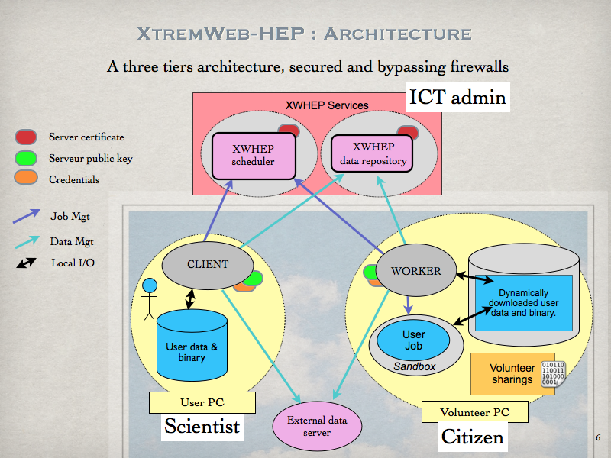Figure 1: Volunteer sharing
Figure 1 shows the architecture of this version, including volunteer sharing. This is still a three tiers architecture with centralized services that ensure the deployment coherency, distributed clients to use and manage the platform, and workers to aggregate volunteer resources.
Compared to the architecture described in the “XtremWeb-HEP Introduction” documentation, we can see the new “volunteer sharing” paradigm on worker side. This represents any object (data, application, library) the worker wishes to propose to the deployment. If the required conditions are met (mainly the security issues), this volunteer sharing may be proposed to users.
It is the volunteer resource owner responsibility to propose or deny volunteer sharing from its resource.

Shared application

There are three requirements to share an application:
- the application must be registered;
- the application type must be greater than ApplicationType.SHARED. Please refer to the “XtremWeb-HEP extended programmer guide”;
- the application must be provided with ”launchscriptshuri” and ”unloadscriptshuri”. Please refer to the “XtremWeb-HEP extended programmer guide”.

Shared library

This is still under development.

Shared data

This is still under development.

Inter node communication

In this version, distributed nodes can now be interconnected. More precisely, applications and jobs run over a deployment may be able to communicate.
This new functionality is manageable by the volunteer resource owner who can switch it on or off.

The distributed parts of the middleware themselves do not gain any new communication facilities: the client cannot connect to any worker and worker cannot communicate to each others.
But client and worker can now create communication tunnels on demand so that jobs running on volunteer resources may have a chance to communicate to applications running on the client side. Jobs running on volunteer resources can also initiate communications to one another. Finally, jobs running on volunteer resources may also be reachable from application running on client side.

Let explain all that by examples. Suppose we have two applications: JackRabbit , which is a standalone version of Apache entirely written in Java language; and wget , which is an non-interactive command line tool for file retrieving over the internet.
We can easily access files from JackRabbit on our desktop grid, in different ways:
- run Jackrabbit on client side and deploy wget over volunteer resources. This could be useful when deploying jobs over XWHEP that need a specific data repository;
- deploy Jackrabbit on volunteer resources and run wget on client side to retrieve data. This could be useful if we want a free hosted data repository;
- deploy Jackrabbit and wget jobs on volunteer resources. This could be useful for a fully distributed data repository solution.

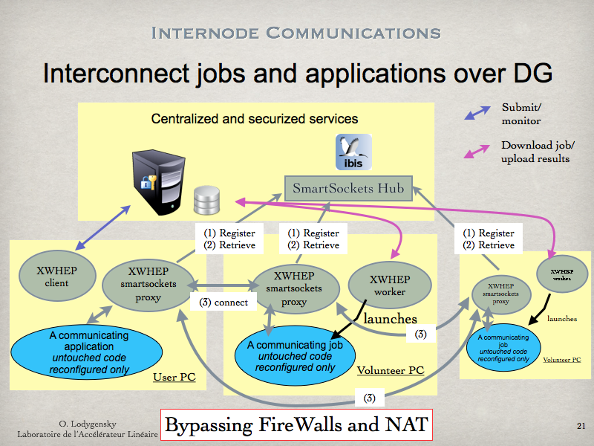Figure 2: Internode communications
All this is achieved using the SmarSockets library. Figure 2 shows the communication architecture. Along the well known centralized XWHEP services, a new centralized service is introduced: the Smartsockets hub which must be installed in a centralized, secured and public server. The XWHEP distributed parts (client and worker) now included a so called “Smartsocket proxy” which is in charge of creating tunnels on demand so that jobs running on volunteer resources may be reachable and can reach other running jobs or applications.
The communication process is as follow: (1) the Smartsocket proxy register on the Smartsocket hub, on client as well as volunteer resource side; (2) the Smartsocket proxy may retrieve on demand distributed communication ends through the Smartsockets hub. Finally, (3) node to node communications may take place.

Security consideration

The middleware is supposed to be run and managed by a non privileged user: it has no chance to use privileged ports (ports lower than 1024).

By the way, even if the middleware has been installed and configured to be run under a privileged account (which is a very bad idea and under the responsibility of the one who did that) the middleware has been written to cowardly refuse to use privileged port.

Port under 1024 are not allowed; if a job has a listening port defined under 1024, this job is not run and its status set to error.

Virtualization over desktop grid

This chapter introduces development, deployment and usage of virtual machines (VM) over the XtremWeb-HEP desktop grid.

To follow this chapter, Virtual-Box (VB) must be installed in you machine. You do not need to create any new VM in VB since the middleware provides scripts to manage VMs: create, start, stop and destroy VMs on demand. Provided scripts do not alter or modify in any manner neither VB itself, nor any existing VM nor virtual disk image (VDI).

The reader should have a minimal understandings on shell languages. This chapter introduces the necessary usage of Virtual-Box (VB) for creating and launching a new virtual machine inside VB.
All instructions in this document are based on Scientific-Linux (SL).

Introduction

This chapter is structured as follow: chapter 4.2 details security regarding the usage of virtual machines over a desktop grid; chapter 4.3 describes the envisioned usage of virtual machine over desktop grid. Chapter 4.4 introduces the contextualization mechanisms.

Security considerations

This chapter describes our “Virtualization Validation Procedure (VVP)”.

The XWHEP server aggregates volunteer resources to remotely launch virtual machines by providing bootable virtual drive (VD), which must be validated following our “Virtualization Validation Procedure”. On another hand VD submitters sign a “Conformance Certificate” that engages their responsibility.
The VVP is conceptually similar to the “Application Validation Procedures” described in the “XtremWeb-HEP introduction” documentation.
This procedure, describing a best effort work, is under deployments administrator responsibility; it consists on checking the points described in next subsections.

Background

Embedded OSes used to launch virtual machines must not contain erroneous or malicious softwares or configurations.
They should specifically be based on a recent version containing last software releases with all known bug fixes and security corrections.

User rights

There must be no way to connect as privileged user.
Non privileged users must not be able to gain any privilege; they must specifically not be allowed to use the “sudo” tool.

Connection security

Embedded OSes must contain and run the “sshd” service (or similar one). Connection to virtual machines must systematically use TLS encryption.
Connections should be challenged using end user certificate.

Network access

Internet access may be allowed from the virtual machine.

Access to local area network (LAN) must not be allowed.

Blocking access to LAN may be done using the “iptables” tools.
The following iptables rules may be used to do so:

*filter

# Input
-P INPUT ACCEPT
# Output
-P OUTPUT ACCEPT
# Routage
-P FORWARD ACCEPT

# Communication allowed on loopback
-A OUTPUT -o lo -j ACCEPT

# Output allowed on established incoming connections
-A OUTPUT -m state --state RELATED,ESTABLISHED -j ACCEPT

# Allow a given port range on output
-A OUTPUT -p tcp --dport 4000:4100 -j ACCEPT

# Deny access to LAN
-A OUTPUT --destination 10.0.0.0/8 -j REJECT
-A OUTPUT --destination 172.16.0.0/12 -j REJECT
-A OUTPUT --destination 192.168.0.0/24 -j REJECT

COMMIT

One may note that these rules still allow accesses to LAN through some ports (4000 to 4100 in our example).

These ports may be used to communicate with the XtremWeb-HEP middleware and should not be used until further notification.

Virtual machines over desktop grid

This chapter details the envisioned solutions proposed within XtremWeb-HEP 8 (XWHEP8) to deploy and use virtual machines over desktop grid.

Deploying and using virtual machines over a desktop grid raises major questions: how to deploy and use a hypervisor needed to manage VM on volunteer resources running desktop Linux, Apple Mac OS X or Microsoft Windows? What about the bandwidth usage to download virtual disks used as bootable media to launch the VM? And how to propose an easy solution to deploy customized VM to the end user?

Next sections show that using Virtual-Box as a volunteer shared application solves the first problem of deploying and using an hypervisor on volunteer resource: we do not need to deploy the hypervisor, we use the one shared by volunteer resources. Section 4.3.4 details our solution to the bandwidth bottleneck. Section 4.4 introduces contextualization, our solution to ease the VM management and usage.

Installation

Using the volunteer sharing technology still necessitates to register shared objects since the XWHEP middleware implements the “pull mode” paradigm where distributed parts are not reachable. This clearly means that, in XWHEP, objects must be registered on server side. This is true for shared objects too: they must be registered on the server in order to be usable over the deployment.
On another hand, registering objects, even shared ones, allows the middleware to apply security mechanisms as described in the “XtremWeb-HEP Introduction” document. This includes authorization, authentication, confinement access rights, logging and bookkeeping.

Registering shared application

In XWHEP, registering application is necessary to allow users to submit jobs that must refer to application. Registering shared applications is detailed in the “XtremWeb-HEP Extended User Guide” document.

Proposing shared application

In XWHEP 8, shared application may be proposed by volunteer resource owners. It is the XWHEP deployment administrator responsibility to encourage them to install the desired application on their volunteer resource and to propose it as a volunteer shared application in the platform.
The volunteer resources can propose whatever they want. Registered shared applications only will be taken in account.

Sharing applications is detailed in the “XtremWeb-HEP Extended Resource Provider Guide” document.

Submitting a virtual machine

In XWHEP 8, submitting jobs is detailed in the “XtremWeb-HEP Extended User Guide” document. This includes job submission referring shared application.
To the end user, there is no difference between submitting jobs referring shared application and submitting jobs referring “deployable” application. This is transparent to the user who is submitting jobs. Please refer to section 3.1 introducing “shared” versus “deployable” objects.
The difference lies on the volunteer resource side and on the fact that the volunteer resources download no binary for shared applications, since the application is supposed to be preinstalled.

In the context of submitting virtual machines to our desktop grid, where users submit jobs referring a shared hypervisor, there is still the problem of the bandwidth usage since submitting virtual machines requires to transfer virtual disks images (VDI) to boot the VM. And VDI may be several giga bytes. And transferring giga bytes over a DG is just inconceivable.

To solve this problem we have decided to encourage the usage of LiveCD since they are a few hundreds mega bytes only. We propose LiveCD with a size about 350Mb on our website.
But LiveCD contains a predetermined operating system that may not fit all end user needs. We propose a solution to modify the OS burnt in the LiveCD: the contextualization introduced in next section.
Section 4.4 describes contextualization mechanisms which are certainly enough for the majority of cases. SectionErreur : source de la référence non trouvée describes how to dynamically create and launch a virtual machine. SectionsErreur : source de la référence non trouvée and Erreur : source de la référence non trouvée explain how to create a new contextualize able LiveCD to fit specific requirements that could not be covered by contextualization only.

Contextualization

A LiveCD contains a full operation system (OS) perennially stored in the media that cannot be modified in any manner. When used as a bootable media for a virtual machine, all modifications are lost if the VM is stopped. On next usage, the OS is still as it was originally when the LiveCD has been created.
It is very likely that an OS burnt on a LiveCD does not fit all possible usages, nor some end user requirements.
We introduce “contextualization” in order to easily permit the usage of a LiveCD for a large field of use cases and requirements.

Introduction to contextualization

We propose LiveCD containing customization mechanisms that permit to modify the embedded OS on the fly. To do so, our LiveCD contains a script run at the end of the boot process, which tries to mount two devices:
- one on /scratch to propose some working spaces where the user can run computation;
- another one on /conxtext. If this device is correctly mounted, the script /context/context.sh is executed, if it exists.

If any these devices do not exist, it is not mounted and the LiveCD continue its boot process.
The script /context/context.sh can contain anything (its content is not checked). It is executed without any administrator privilege. It may contains commands to install the end user public key so that the user will be able to connect to its VM using ssh; or it can contain command to install some specific packages or libraries. Etc.

The contextualization script is run without any privileged rights. Hence there are a lot of things that are not allowed. If your script needs privileged rights, you should not use contextualization. In this case, you must create your own LiveCD as described in chaptersErreur : source de la référence non trouvée andErreur : source de la référence non trouvée.

Figure 3 shows the contextualization environment.
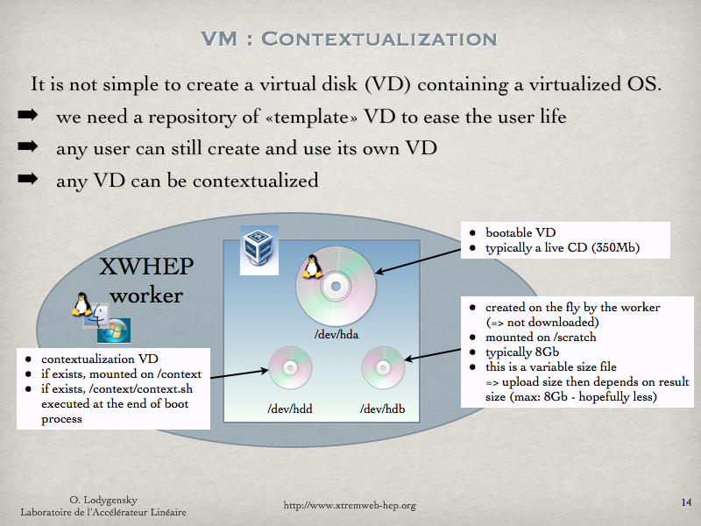Figure 3 : LiveCD customization

Contextualization structure

The customization is done by providing a virtual disk (VD) to our script described in chapter Erreur : source de la référence non trouvée. This VD must contains a script named ”context.sh” in its root (outside any directory). The middleware proposes an example of this script in:
- ${XWHEP_HOME}/bin/context.sh

In the middleware source package this script is in:
- ${XWHEP_HOME}/src/script/

If available, this script is run at the end of the boot process. It may contain any command, keeping in mind that it is run without any administrator privilege.

Create a new contextualization disk

Please refer to chapter Erreur : source de la référence non trouvée.

Virtual machines provision

Our new web site http://www.flyinggrid.org proposes ready to used virtual disk images gallery.
You are invited to download the one that fit your requirements.

Contacts

If you need help contact XWHEP team : xtremweb (at) lal.in2p3.fr

The XWHEP website : http://www.xtremweb-hep.org

You can find RPM and Mac OS X packages at this address :
http://www.xtremweb-hep.org/spip.php?article52

Membership request to VO :
https://grid12.lal.in2p3.fr:8443/voms/vo.lal.in2p3.fr/Siblings.do

Third party libraries

jLite library :
http://code.google.com/p/jlite/

Bouncy Castle library :
http://www.bouncycastle.org/

Jetty library :
http://jetty.codehaus.org/jetty/

SmartSockets library :
http://www.cs.vu.nl/ibis/ipl.html

Index
Index lexical
Bouncy Castle 18
Conformance Certificate 11
deployable 7
HOME 4
hypervisor 13
Jetty 18
jLite 18
LiveCD 14
local area network 12
SmarSockets 9
SmartSockets 18
TLS 12
VDI 11
virtual disk 14
VDI 14
virtual machine 11, 13, 14
Virtualization Validation Procedure 11
XWHEP_HOME 4
XWHEP_VERSION 4
18

We call it “FlyingGrid” since we wish to propose a known flying object to reach the cloud.
http://www.flyinggrid.org
Object registration is detailed in the standard documentation.
http://jackrabbit.apache.org
http://www.gnu.org/s/wget/
http://www.cs.vu.nl/ibis/smartsockets.html
http://en.wikipedia.org/wiki/Virtual_disk_image
http://www.virtualbox.org
http://www.scientificlinux.org
http://en.wikipedia.org/wiki/sudo
http://en.wikipedia.org/wiki/Hypervisor
http://en.wikipedia.org/wiki/Live_CD

