XtremWeb-HEP 8
“FlyingGrid”
Programmer Guide
Version 1.3.0

Table of Contents
1 Introduction 3
1.1 Audience 3
1.2 Software license agreement 3
1.3 Reading conventions 4
1.4 Middleware Versioning 4
1.5 Documentation Versioning 5
1.5.1 Version 1.0.0 5
1.5.2 Version 1.1.0 5
1.5.3 Version 1.1.1 5
1.5.4 Version 1.2.0 5
1.5.5 Version 1.3.0 6
2 Introduction to XtremWeb-HEP middleware 6
3 The XtremWeb-HEP source package 6
3.1 The package structure 6
3.2 The source structure. 7
3.3 Constructing the binary package 7
3.3.1 Preparing the compilation 8
3.3.2 Customising the server embedded web page 11
3.3.3 Customising the server statistics embedded web page 11
3.3.4 Customising the worker embedded configuration web page 12
3.3.5 Compiling the source package 12
3.3.6 The binary package structure 13
3.4 Installing and deploying the middleware 13
3.5 Code quality 13
3.5.1 Junit tests 13
3.5.2 Code coverage 14
3.5.3 Sonar code quality management 14
4 Objects definitions in the XtremWeb-HEP middleware 16
4.1 The database schema 17
4.2 Data definition 18
4.2.1 Data attributes 18
4.2.2 Data XML representation 20
4.3 Application definition 20
4.3.1 Application attributes 20
4.3.2 Application XML representation 23
4.4 Group definition 24
4.4.1 Group attributes 24
4.4.2 Group XML representation 24
4.5 Host definition 25
4.5.1 Host attributes 25
4.5.2 Host XML representation 29
4.6 Session definition 29
4.6.1 Session attributes 29
4.6.2 Session XML representation 30
4.7 Task definition 30
4.7.1 Task attributes 30
4.7.2 Task XML representation 32
4.8 Trace definition 32
4.9 Usergroup definition 32
4.9.1 User group attributes 33
4.9.2 User group XML representation 33
4.10 User definition 33
4.10.1 User attributes 34
4.10.2 User XML representation 36
4.11 Work definition 36
4.11.1 Work attributes 36
4.11.2 Work XML representation 40
5 List of constants 41
5.1 Object status 41
5.2 User rights 42
5.3 Managed Operating Systems 43
5.4 Managed CPU architectures 43
5.5 Application Types 44
5.6 Data Types 44
6 Job state graph 45
7 Contacts 47
8 Third party libraries 47
9 Index 48

Index des illustrations
Figure 1: Sonar code quality report 15
Figure 2: XtremWeb-HEP database schema 17
Illustration 3: XtremWeb-HEP job state graph 46

Introduction

This document is part of the XtremWeb-HEP middleware documentation which contains different documents: “XtremWeb-HEP Introduction”, “XtremWeb-HEP User Guide”, “XtremWeb-HEP Administrator Guide”, “XtremWeb-HEP Resource Provider Guide” and this one, “XtremWeb-HEP Programmer Guide”.

The name of XtremWeb-HEP is shortened as XWHEP.

On July 2012:
- “XtremWeb-HEP Introduction 1.3.0” has been released;
- “XtremWeb-HEP Programmer Guide 1.2.0” has been released;
- “XtremWeb-HEP Administrator Guide 1.3.0” has been released;
- “XtremWeb-HEP User Guide 1.4.0” has been released;
- “XtremWeb-HEP Resource Provider Guide 1.1.0” has been released.

Audience

Anyone who would like to understand the XtremWeb-HEP middleware internals should read this document.

Software license agreement

XtremWeb-HEP is an open source software provided under the GPL2 license (http://www.gnu.org/licenses/gpl-2.0.html).

BECAUSE THE PROGRAM IS LICENSED FREE OF CHARGE, THERE IS NO WARRANTY FOR THE PROGRAM, TO THE EXTENT PERMITTED BY APPLICABLE LAW. EXCEPT WHEN OTHERWISE STATED IN WRITING THE COPYRIGHT HOLDERS AND/OR OTHER PARTIES PROVIDE THE PROGRAM "AS IS" WITHOUT WARRANTY OF ANY KIND, EITHER EXPRESSED OR IMPLIED, INCLUDING, BUT NOT LIMITED TO, THE IMPLIED WARRANTIES OF MERCHANTABILITY AND FITNESS FOR A PARTICULAR PURPOSE. THE ENTIRE RISK AS TO THE QUALITY AND PERFORMANCE OF THE PROGRAM IS WITH YOU. SHOULD THE PROGRAM PROVE DEFECTIVE, YOU ASSUME THE COST OF ALL NECESSARY SERVICING, REPAIR OR CORRECTION.

IN NO EVENT UNLESS REQUIRED BY APPLICABLE LAW OR AGREED TO IN WRITING WILL ANY COPYRIGHT HOLDER, OR ANY OTHER PARTY WHO MAY MODIFY AND/OR REDISTRIBUTE THE PROGRAM AS PERMITTED ABOVE, BE LIABLE TO YOU FOR DAMAGES, INCLUDING ANY GENERAL, SPECIAL, INCIDENTAL OR CONSEQUENTIAL DAMAGES ARISING OUT OF THE USE OR INABILITY TO USE THE PROGRAM (INCLUDING BUT NOT LIMITED TO LOSS OF DATA OR DATA BEING RENDERED INACCURATE OR LOSSES SUSTAINED BY YOU OR THIRD PARTIES OR A FAILURE OF THE PROGRAM TO OPERATE WITH ANY OTHER PROGRAMS), EVEN IF SUCH HOLDER OR OTHER PARTY HAS BEEN ADVISED OF THE POSSIBILITY OF SUCH DAMAGES.

Reading conventions

Code examples appear in grey boxes
$> ./proxy-init.sh desktopgrid.vo.edges-grid.eu
Enter your private key passphrase:
Created VOMS proxy: O=GRID-FR,C=FR,O=CNRS,OU=LAL,CN=Oleg Lodygensky,CN=proxy
Proxy is valid until: Fri Nov 19 21:59:37 2010 CET
Proxy location: /var/folders/0R/0RQqVNNAEpqqeXUidaIL0++++TM/-Tmp-/x509up_u_mboleg

Variables appear in courier font, within '${' and '}', just as “${VARIABLE}”. They should be understood and replaced by their values.

Some variables used in this document:
${XWHEP_VERSION} is the current version of our middleware
${XWHEP_HOME} is the directory where the middleware is installed
${HOME} is the user home directory

Sometimes there are some inputs the reader must provide. These appear in courier font, within '<' and '>', just as “<your input>”.

Middleware Versioning

Middleware versioning is as follow
- X is the major part of the version
- Y is the minor part of the version
- Z is the micro part of the version

(*) X reports a very important change: for example the communication protocol changes or a major new feature is modified/introduced/removed
When X changes, backward compatibility is not ensured

(*) Y reports an important but not critical change: backward compatibility is ensured

(*) Z reports a minor change: bug correction, documentation changes etc.

In June 2013, the last version of XtremWeb-HEP is 8.2.2.
In this document we refer that version as the current version and refer it as ${XWHEP_VERSION}.

Documentation Versioning

Documentation versioning is as follow
- X is the major part of the version
- Y is the minor part of the version
- Z is the micro part of the version

Version 1.0.0

Date: May, 2011
Authors: O. Lodygensky
Reviewers:

- Initial document.

Version 1.1.0

Date: Sept, 2011
Authors: O. Lodygensky
Reviewers:

- XWHEP 7.6.0 introduces URI pass through to enable more than one file as job environment.

Version 1.1.1

Date: Dec, 2011
Authors: O. Lodygensky
Reviewers:

- Some more description in objects attributes

Version 1.2.0

Date: July 17th, 2012
Authors: O. Lodygensky
Reviewers:

- Merging “extended programmer's guide”

Version 1.3.0

Date: November 19th, 2012
Authors: O. Lodygensky
Reviewers:

- Introducing code quality management

Version 1.4.0

Date: June 18th, 2013
Authors: O. Lodygensky
Reviewers:

- Detailing embedded Web page customization

Introduction to XtremWeb-HEP middleware

Please refer to the “XtremWeb-HEP Introduction” document.

The XtremWeb-HEP source package

The source package contains all files that make the XtremWeb-HEP middleware, from Java source to documentation.
One can download the package from http://www.xtremweb-hep.org.

The package structure

The package is structured as follow:
- some general information files:
- AUTHORS; the authors file.
- ChangeLog; the last version change log.
- INSTALL; a quick start guide.
- Track_report.html; the version trac report.
- some license files:
- License: the XtremWeb-HEP license file.
- License.bouncycastle; the bouncycastle license.
- a make file: Makefile;
- some directories:
- benchmark/; scripts and binary to test and benchmark the software.
- build/; scripts, XML and make file to compile the software.
- classes/; external java packages.
- doc/; documentation.
- installers/; installation package sources.
- misc/; icons, configuration and embedded html files.
- php/; web page sources.
- src/; “Java” and “C” sources.

Each directory may contain some additional files and/or directories. They may be detailed in following sections.

The source structure.

The src/ directory is made of several subdirectories:
- antlr/: containing methods.g, a grammatical description file not used to parse java invocation method.
- natif/: “C” and “C++” sources dynamically linked to java packages.
- scripts/: shell and SQL scripts to manage and use the middleware.
- xtremweb/: the middleware Java source.
- misc/: manifest files to generate Java archive files; icon files to be displayed in tray box; worker html pages for the worker configurer (see chapter 3.3.2).

Constructing the binary package

The middleware compilation process is describe in the “build.xml” file passed to ant.
Compiling is executed by calling make. Prior to compile, the “build.conf” file must be edited so that all variable defined as “must be filled” should be assigned a value. If any expected variable is not correctly set, an error occus and the following message is displayed:

$> make
JAVA_HOME env variable is set (JAVA_HOME = /Library/Java/Home/)
*****
*****
***** ERROR: Your build.conf file is not filled properly
*****
*****

make: *** [%] Error 3
$>

Preparing the compilation

The “build.conf “ file contains several variables that needs to be correctly set before compiling the middleware. These variables are mainly used to create installation packages.
This section detail all variables as found in the “build.conf “ file. Variable list is formatted as follow:

variable name
Comment : what it is
Type : variable type (e.g. string)
Default : default value, if any

system.user
Comment : the login to be used to run the middleware server and/or worker components; this is not used to run the client part.
This is not used under win32.
This is the connection from “service layer” to “os layer” in “xtremweb-hep introduction: secure resources”
Type : string

xtremweb.admin.login
Comment : this is the login part of the administrator credential to connect to the xwhep server. This will be used by the client part.
This is the connection from “middleware layer” to “service layer” in “xtremweb-hep introduction: secure resources”
Type : string

xtremweb.admin.password
Comment : this is the password part of the administrator credential to connect to the xwhep server. This will be used by the client part.
This is the connection from “middleware layer” to “service layer” in “xtremweb-hep introduction: secure resources”
Type : string

xtremweb.worker.login
Comment : this is the login part of the worker credential to connect to the xwhep server. This will be used by the worker part.
This is the connection from “middleware layer” to “service layer” in “xtremweb-hep introduction: secure resources”
Type : string

xtremweb.worker.password
Comment : this is the password part of the worker credential to connect to the xwhep server. This will be used by the worker part.
This is the connection from “middleware layer” to “service layer” in “xtremweb-hep introduction: secure resources”
Type : string
Access : required

dispatcher.servers
Comment : this is a comma separated list of xwhep server
Type : string

data.servers
Comment : this is a comma separated list of xwhep data server; if not set, “dispatcher.servers” is used
Type : string
Default : null

launcher.url
Comment : this is an url where distributed parts may update the software
Type : url
Default : null

db.system
Comment : this is the database system name
Must be “mysql” or “hsqldb”
Type : string

db.host
Comment : this is the database server name or ip address
Type : string

db.engine
Comment : this is the database engine.
May be “disk” or “memory”.
When using “memory”, permanence is not ensured (e.g. submitted jobs are lost if the server restarts)
Type : string
default : disk

db.su.login
Comment : this is the database administrator login
If you don't have it, database must be first prepared by a database administrator
Type : string
default : null

db.su.pasword
Comment : this is the database administrator password
If you don't have it, database must be first prepared by a database administrator
Type : string
Default : null

db.user.login
Comment : this is the user login the server will use to connect to the db
Type : string

db.user.pasword
Comment : this is the user password the server will use to connect to the db
Type : string

db.name
Comment : this is the database name
Type : string

install.dir
Comment : this is the installation directory
Type : string
Default : /opt

install.www.dir
Comment : this is the directory where to install php files
Type : string
Default : null

ganglia.www.dir
Comment : this is the directory where to install ganglia files
Type : string
Default : null

xw.server.keypassword
Comment : this is the password to secure the keystore
Type : string

xw.worker.keypassword
Comment : this is the password to secure the keystore
Type : string

xw.client.keypassword
Comment : this is the password to secure the keystore
Type : string

xw.keypassphrase
Comment : this is the passphrase to secure the server private key
Type : string

sonar.host.url
Comment : This is the Sonar server address (please refer to chapter3.5)
Type : url

sonar.jdbc.url
Comment : This is the Sonar database server address (please refer to chapter3.5)
Type : url

sonar.jdbc.username
Comment : This is the Sonar database user name (please refer to chapter3.5)
Type : url

sonar.jdbc.password
Comment : This is the Sonar database user password (please refer to chapter3.5)
Type : url

Customising the server embedded web page

The server has an embedded web page to permit user to use the platform (submit job, retrieve results etc.). This web page is served by the jetty embedded web server; hence user can use a standard web browser..
The server web page is the html page: “misc/xwserver.html”. This document is embedded in the server and refers other documents:
- a javascript page: “misc/xwserver.js”; this is available at “http://www.xtremweb-hep.org/lal/xwserver.js”;
- another javascript page: “misc/xwserver_d3.js”; this is available at “http://www.xtremweb-hep.org/lal/xwserver_d3.js”;
- the style page: “misc/xwserver.css”;
- the logo image: “misc/logo.jpg” (this must be a jpeg file).

You can customise any of these documents to reflect your deployment, your organisation etc. If so, it is your responsibility to ensure its integrity, especially taking attention on leaving the scripts fully functional.

Customising the server statistics embedded web page

The server has a statistics embedded web page to permit user to see the statistics platform (amount of submitted jobs etc.). This web page is served by the jetty embedded web server; hence user can use a standard web browser..
The server statistics web page is the HTML page: “misc/serverstats.html”. This very simple page has a few HTML source code lines only. You can customise this page to reflect your deployment, your organisation etc. If you edit this page, it is your responsibility to ensure its integrity and functionality.

Customising the worker embedded configuration web page

The worker has an embedded configuration tool to permit the volunteer resource owner to manage (start, stop and customize) its local worker. The embedded configuration tool is the jetty embedded web server; hence the volunteer resource owner can use a standard web browser to configure its local worker.
The configuration page is the html page: “misc/worker.html”. This page includes CSS, JavaScript and html source codes. You can customise this page to reflect your deployment, your organisation etc. If you edit this page, it is your responsibility to ensure its integrity, especially taking attention on leaving the scripts fully functional.

Compiling the source package

To compile the source package, you need Java 1.6.0 JDK.
You must set the JAVA_HOME environment variable. If this variable is not set, you have the following error message:

$> make

**** You must first set JAVA_HOME env variable ****
**** Please set you Java installation ****

make: *** [%] Error 1
$>

Invoking “make” with no argument compiles and installs the binary distribution.
If everything goes well, you have the message just like the following:

$> make

...
... a lot of messages ...
...

BUILD SUCCESSFUL
Total time: 18 seconds
JAVA_HOME env variable is set (JAVA_HOME = /Library/Java/Home/)
build.conf OK

$>

The binary package structure

When invoking “make” has been successful, the binary package is ready in the “dist/” directory where there must be an “xwhep-${XWHEP_VERSION}” subdirectory.

Installing and deploying the middleware

Please refer to the “XtremWeb-HEP Administrator guide”.

Code quality

Code quality management has been introduced since XWHEP 8.2.0, using Sonar and Junit.
The middleware comes with all necessary tools and libraries to monitor code quality.

Junit tests

Please consider reading the JUnit documentations first at http://junit.sourceforge.net/.

The XWHEP sources contains Junit tests. For example, src/xtremweb/common/ may be tested by by its test implementations contained in src/xtremweb/common/test.

The XWHEP make file contains a “junit” entry to generate Junit test reports, as shown below:

$> make junit

...
... a lot of messages ...
...

BUILD SUCCESSFUL
Total time: 18 seconds
JAVA_HOME env variable is set (JAVA_HOME = /Library/Java/Home/)
build.conf OK

$>

These test reports are then automatically taken into account in code quality management reports as described in next section.

Code coverage
Not written yet

Sonar code quality management

Please consider reading the Sonar documentations first at http://www.sonarsource.org since this expects to install and manage a code management server.
Sonar server installation and management remain the end user responsibility and is not described in this documentation.

To manage code quality, one have to set three different variables in the the “build.xml” file, as described in chapter3.3.1:
- sonar.host.url must contain the sonar server url. If you have installed your Sonar server on the machine where you want to manage XWHEP code quality, this should be http://localhost:9000.
- sonar.jdbc.url must contain your Sonar database server. If you have configured your Sonar server on local machine, with the default h2 embedded database engine, this should be http://localhost:9092.
- sonar.jdbc.username sonar. This the login to connect to your Sonar database server. The default h2 embedded database engine expects “sonar” as login.
- sonar.jdbc.password. This the password to connect to your Sonar database server. The default h2 embedded database engine expects “sonar” as password.

The XWHEP make file contains a “sonar” entry to generate code quality reports, as shown below. This automatically takes into account code coverage and JUnit test reports, if available.

$> make sonar

...
... a lot of messages ...
...

BUILD SUCCESSFUL
Total time: 18 seconds
JAVA_HOME env variable is set (JAVA_HOME = /Library/Java/Home/)
build.conf OK

$>

This generates a new code quality report in your server. You can access you server using your favourite web browser as shown in figure 1.
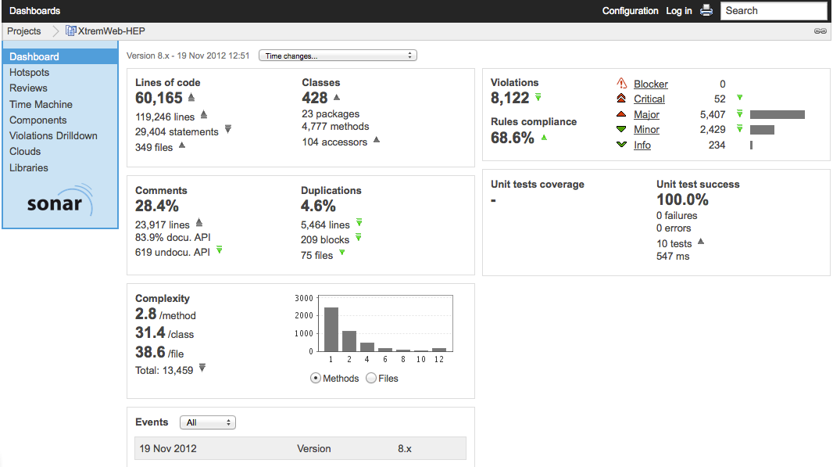Figure 1: Sonar code quality report

Objects definitions in the XtremWeb-HEP middleware

The reader can find here definitions of objects as defined in XWHEP.
The first section introduces the database schema; next sections detail objects definition.

In those sections, definition lists are formatted as follow:

attribute name
Comment : what it is
Type : attribute type (e.g. String)
Access : public | required | auto | optional
public: the user may set/edit this attribute
required: the user must set this attribute
auto: the attribute is automatically calculated by the middleware
optional: may be empty
Relation : this defines if this attribute is linked to another object type
Default : default value
Since : version number

The database schema
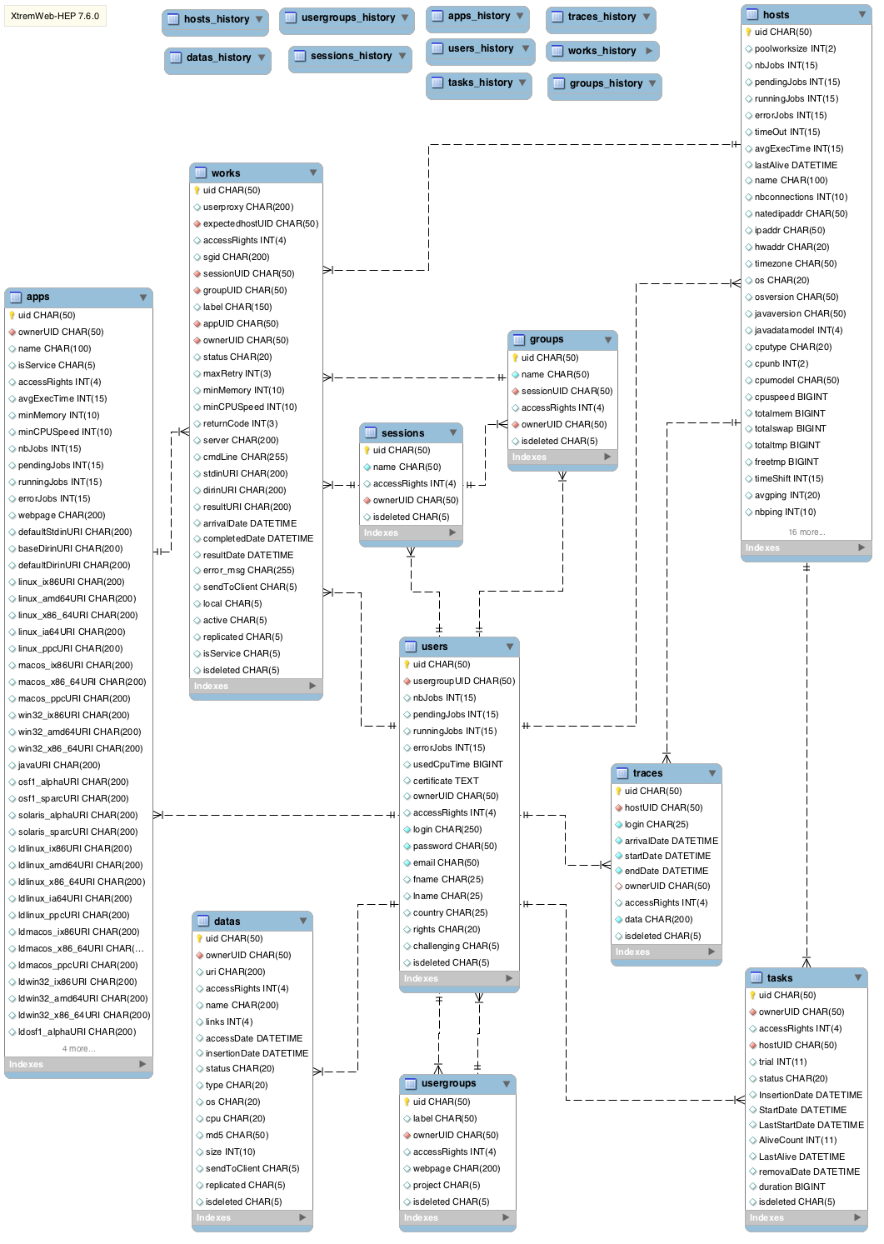Figure 2: XtremWeb-HEP database schema

Figure 2 shows the XWHEP database schema where we find twenty tables divided in two groups of ten tables each: the “production“ and the “history” group.
Figure 2 details the production tables and shows the history tables header only.

The production group is made of the following tables:
- apps containing registered applications;
- datas containing registered datas;
- groups containing registered groups;
- hosts containing registered volunteer computers;
- sessions containing registered sessions;
- traces containing traces;
- tasks containing registered tasks;
- usergroups containing registered user groups;
- users containing registered users;
- works containing registered works.

The history group ensures logging and bookkeeping. It is a copy of the production group where all rows of any table are copied on deletion.
When an user deletes an object, it is first copied into history table, then deleted from production table.

All tables have at least three columns:
- “uid” is a string containing the unique identifier of the row (or object);
- “owneruid” is a string containing the unique identifier of the owner;
- “accessrights” is an integer containing the access rights to the object.

All tables are linked to the “users” table through the “owneruid” field.

Next sections detail objects definition and table relations.

Data definition

This class defines data usable by the middleware. Data may migrate between the XWHEP components. They are used to define application binary or library among others.

Data attributes

uid
Comment : this is the unique identifier
Type : uuid
Access : auto

owneruid
Comment : this is the unique identifier of the owner
Type : uuid
Access : auto
Relation : users

accessrights
Comment : this defines access rights to this object
Type : integer
Access : auto

name
Comment : this defines the name of this object
Type : string
Access : required

links
Comment : this is the number of references to this object
Type : integer
Access : auto

insertiondate
Comment : this defines the date of insertion
Type : date
Access : auto

accessdate
Comment : this defines the lasta access date
Type : date
Access : auto

status
Comment : this defines the status; please refer to chapter 5.1
Type : string
Access : auto

type
Comment : this defines the type; please refer to chapter 5.6
Type : string
Access : optional

cpu
Comment : this defines the cpu type; please refer to chapter 5.4
Type : string
Access : optional

os
Comment : this defines the os type; please refer to chapter 5.3
Type : string
Access : optional

size
Comment : this defines the size
Type : integer
Access : auto

md5
Comment : this defines the md5
Type : string
Access : auto

uri
Comment : this defines the uri
Type : string
Access : auto

Data XML representation

The command to retrieve the data XML representation and its output are:

$> java -cp ${XWHEP_HOME}/lib/xtremweb.jar xtremweb.common.DataInterface
<xwhep version="7.6.2-head"><data uid="22d5d59b-f06a-469c-9d81-d3419977dcfb" owneruid="NULL" accessrights="0x755" name="NULL" links="NULL" insertiondate="NULL" accessdate="NULL" status="NULL" type="NULL" cpu="NULL" os="NULL" size="NULL" md5="NULL" uri="NULL" sendtoclient="false" isdeleted="false" replicated="false" /></xwhep>
$>

Application definition

This class defines object that must be referred by works to run on volunteer resources.

Application attributes

uid
Comment : this is the unique identifier
Type : uuid
Access : auto

owneruid
Comment : this is the unique identifier of the owner
Type : uuid
Access : auto
Relation : users

accessrights
Comment : this defines access rights to this object
Type : integer
Access : auto

name
Comment : this defines the name of this object
Type : string
Access : required

isservice
Comment : this is true if this application is a service (implementing the service api)
Type : boolean
Access : public

avgexectime
Comment : this is the average execution time calculated as jobs referring this application are completed
Type : integer
Access : auto

minmemory
Comment : this is the minimum amount of memory to run this application
Type : integer
Access : optional

mincpuspeed
Comment :this is the minimum cpu clock to run this application
Type : integer
Access : optional

nbjobs
Comment : this is amount of completed jobs for this application
Type : integer
Access : auto

pendingjobs
Comment : this is amount of pending jobs for this application
Type : integer
Access : auto

runningjobs
Comment : this is amount of running jobs for this application
Type : integer
Access : auto

errorjobs
Comment : this is amount of erroneous jobs for this application
Type : integer
Access : auto

webpage
Comment : this is the web page of this application
Type : url
Access : optional

defaultstdin
Comment : this is the uri of the default standard input file of this application that are sent to all jobs that do not define any stdin
Type : uri
Access : optional
Relation : datas

defaultdirin
Comment : this is the uri of the default environment of this application that are sent to all jobs that do not define any
Type : uri
Access : optional
Relation : datas

basedirin
Comment : this is the uri of the base environment of this application that are always sent to all jobs
Type : uri
Access : optional
Relation : datas

launchscriptshuri
Comment : this is the uri of the shell script to start the shared application
Type : uri
Access : optional
Relation : datas
Since : 8.0.0

launchscriptcmduri
Comment : this is the uri of the windows shell script to start the shared application
Type : uri
Access : optional
Relation : datas
Since : 8.0.0

unloadscriptshuri
Comment : this is the uri of the shell script to stop the shared application
Type : uri
Access : optional
Relation : datas
Since : 8.0.0

unloadscriptcmduri
Comment : this is the uri of the windows shell script to stop the shared application
Type : uri
Access : optional
Relation : datas
Since : 8.0.0

envvars
Comment : this is a comma separated list of environment variables
(e.g. “env1=var1,env2=var2”)
Type : string
Access : optional
Since : 8.0.0

neededpackages
Comment : this is a comma separated list of packages
Type : string
Access : optional
Since : 8.0.0

applicationtype
Comment : this is a string defining the application type.
This must be one of the xtremweb.common.ApplicationType.java.
Please refer to the “xwhep introduction” document.
Type : string
Access : required
Since : 8.0.0

Application XML representation

The command to retrieve the application XML representation and its output are:

$> java -cp ${XWHEP_HOME}/lib/xtremweb.jar xtremweb.common.AppInterface
<xwhep version="7.6.2-head"><app uid="c8223658-9a67-4d17-a96b-a8f57694ec5b" owneruid="NULL" name="NULL" isservice="false" isdeleted="false" accessrights="0x755" avgexectime="NULL" minmemory="NULL" mincpuspeed="NULL" nbjobs="NULL" pendingjobs="NULL" runningjobs="NULL" errorjobs="NULL" webpage="NULL" defaultstdinuri="NULL" basedirinuri="NULL" defaultdirinuri="NULL" ldlinux_ix86uri="NULL" ldlinux_x86_64uri="NULL" ldlinux_amd64uri="NULL" ldlinux_ia64uri="NULL" ldlinux_ppcuri="NULL" ldmacos_ix86uri="NULL" ldmacos_x86_64uri="NULL" ldmacos_ppcuri="NULL" ldwin32_ix86uri="NULL" ldwin32_amd64uri="NULL" ldwin32_x86_64uri="NULL" ldosf1_alphauri="NULL" ldosf1_sparcuri="NULL" ldsolaris_alphauri="NULL" ldsolaris_sparcuri="NULL" linux_ix86uri="NULL" linux_amd64uri="NULL" linux_x86_64uri="NULL" linux_ia64uri="NULL" linux_ppcuri="NULL" macos_ix86uri="NULL" macos_x86_64uri="NULL" macos_ppcuri="NULL" win32_ix86uri="NULL" win32_amd64uri="NULL" win32_x86_64uri="NULL" javauri="NULL" osf1_alphauri="NULL" osf1_sparcuri="NULL" solaris_alphauri="NULL" solaris_sparcuri="NULL" /></xwhep>
$>

Group definition

Group aggregates jobs so that they can be managed as a single object.

Group attributes

uid
Comment : this is the unique identifier
Type : uuid
Access : auto

owneruid
Comment : this is the unique identifier of the owner
Type : uuid
Access : auto
Relation : users

accessrights
Comment : this defines access rights to this object
Type : integer
Access : public

name
Comment : this defines the name of this object
Type : string
Access : public

sessionuid
Comment : this defines the uid of the session if any
Type : uuid
Access : required
Relation : sessions

Group XML representation

The command to retrieve the group XML representation and its output are:

$> java -cp ${XWHEP_HOME}/lib/xtremweb.jar xtremweb.common.GroupInterface
<xwhep version="7.6.2-head"><group uid="47c4c98e-25bc-4f39-817d-6aeb883595ea" name="NULL" sessionuid="NULL" isdeleted="false" accessrights="0x700" owneruid="NULL" /></xwhep>
$>

Host definition

This class defines volunteer resource attributes.

Host attributes

uid
Comment : this is the unique identifier
Type : uuid
Access : auto

owneruid
Comment : this is the unique identifier of the owner
Type : uuid
Access : auto
Relation : users

accessrights
Comment : this defines access rights to this object
Type : integer
Access : auto

name
Comment : this defines the name of this object
Type : string
Access : auto

nbconnections
Comment : this defines the amount of connections
Type : integer
Access : auto

ipaddr
Comment : this defines the internet public address
Type : string
Access : auto

natedipaddr
Comment : this defines the internet private address
Type : string
Access : auto

hwaddr
Comment : this defines the ethernet mac address
Type : string
Access : auto

timezone
Comment : this defines the time zone of the worker
Type : string
Access : auto

nbping
Comment : this defines the amount of ping issued by this worker
Type : integer
Access : auto

avgping
Comment : this defines the ping average
Type : float
Access : auto

uploadbandwidth
Comment : this defines the upload bandwidth average
Type : float
Access : auto

downloadbandwidth
Comment : this defines the download bandwidth average
Type : float
Access : auto

os
Comment : this defines the operating system name
Type : string
Access : auto

osversion
Comment : this defines the operating system version
Type : string
Access : auto

cputype
Comment : this defines the type of the cpu
Type : string
Access : auto

cpumodel
Comment : this defines the model of the cpu
Type : string
Access : auto

cpunb
Comment : this defines the amount of detected cpu cores
Type : integer
Access : auto

cpuspeed
Comment : this defines the clock rate of the cpu
Type : integer
Access : auto

totalmem
Comment : this defines the amount of memory
Type : integer
Access : auto

totalswap
Comment : this defines the amount of swap
Type : integer
Access : auto

totaltmp
Comment : this defines the space on partition the worker is installed
Type : integer
Access : auto

freetmp
Comment : this defines the free space on partition the worker is installed
Type : integer
Access : auto

javaversion
Comment : this defines the javaversion
Type : string
Access : auto

javadatamodel
Comment : this defines the java data model: 32 or 64 bits
Type : integer
Access : auto

poolworksize
Comment : this defines the amount of jobs a worker may compute simultaneously
Type : integer
Access : public

project
Comment : this defines the project the worker want to compute for
Type : string
Access : public
Relation : usergroups

lastalive
Comment : this defines the last time the worker sends an alive signal
Type : date
Access : auto

active
Comment : this defines this worker status
Type : boolean
Access : auto

available
Comment : this defines this worker availability according to its local activation policy
Type : boolean
Access : auto

pilotjob : this is deprecated and replaced by sgid
Comment : this defines if this worker is running on a service grid resource
Type : boolean
Access : public

sgid
Comment : if this worker is running on a service grid resource, this is the service grid identifier
Type : boolean
Access : auto

cpuload
Comment : this is the max cpu usage allowed by the owner of the volunteer resource
Type : integer
Access : public
Since : 8.0.0

incomingconnections
Comment : this tells if the owner of this volunteer resource allows to create communication tunnels
Type : boolean
Access : public
Since : 8.0.0

sharedapps
Comment : this string contains a comma separated list of application shared by this volunteer resource
Type : string
Access : public
Since : 8.0.0

shareddatas
Comment : this string contains a comma separated list of data shared by this volunteer resource
Type : string
Access : public
Since : 8.0.0

sharedpackages
Comment : this string contains a comma separated list of application packages (e.g. software library) shared by this volunteer resource
Type : string
Access : public
Since : 8.0.0

Host XML representation

The command to retrieve the host XML representation and its output are:

$> java -cp ${XWHEP_HOME}/lib/xtremweb.jar xtremweb.common.HostInterface
<xwhep version="7.6.2-head"><host uid="8a76dbe2-0df2-49a3-a71e-8a0ddbfaf15a" jobid="NULL" batchid="NULL" name="NULL" nbconnections="NULL" natedipaddr="NULL" ipaddr="NULL" hwaddr="NULL" timezone="NULL" avgping="NULL" nbping="NULL" uploadbandwidth="NULL" downloadbandwidth="NULL" os="NULL" osversion="10.6.8" javaversion="1.6.0_26" javadatamodel="64" poolworksize="NULL" cputype="NULL" cpunb="NULL" cpumodel="NULL" cpuspeed="NULL" totalmem="NULL" totalswap="NULL" totaltmp="NULL" freetmp="NULL" owneruid="NULL" accessrights="0x755" project="NULL" lastalive="NULL" active="true" isdeleted="false" available="true" pilotjob="false" sgid="NULL" timeout="NULL" traces="false" avgexectime="NULL" timeshift="NULL" acceptbin="true" version="NULL" pendingjobs="NULL" runningjobs="NULL" errorjobs="NULL" nbjobs="NULL" /></xwhep>
$>

Session definition

Session aims to aggregate jobs so that they can be managed as a single object. Sessions are automatically removed (and all its associated jobs) when the owner sends the disconnect message.

Session attributes

uid
Comment : this is the unique identifier
Type : uuid
Access : auto

owneruid
Comment : this is the unique identifier of the owner
Type : uuid
Access : auto
Relation : users

accessrights
Comment : this defines access rights to this object
Type : integer
Access : public

name
Comment : this defines the name of this object
Type : string
Access : required

Session XML representation

The command to retrieve the session XML representation and its output are:

$> java -cp ${XWHEP_HOME}/lib/xtremweb.jar xtremweb.common.SessionInterface
<xwhep version="7.6.2-head"><session uid="66531842-81ab-4c85-89e3-6e7486b3ff42" name="NULL" isdeleted="false" accessrights="0x700" owneruid="NULL" /></xwhep>
$>

Task definition

Task associates a work to a host.

Task attributes

uid
Comment : this is the unique identifier
Type : uuid
Access : auto

workuid
Comment : this is the uid of the associated work
Type : unique identifier
Access : auto
Since : 8.0.0

owneruid
Comment : this is the unique identifier of the owner
Type : uuid
Access : auto
Relation : users

accessrights
Comment : this defines access rights to this object; this is a copy of the referred work access rights
Type : integer
Access : auto

hostuid
Comment : this is the unique identifier of the host running the associated work
Type : uuid
Access : auto
Relation : hosts

trial
Comment : this is the amount of computing trial
Type : integer
Access : auto

status
Comment : this is the status of this object (see chapter 5.1)
Type : integer
Access : auto

insertiondate
Comment : this is the date this task has been inserted in scheduler queue
Type : date
Access : auto

startdate
Comment : this is the date this task has been first sent to a computing resource
Type : date
Access : auto

laststartdate
Comment : this is the last date this task has first sent to a computing resource
Type : date
Access : auto

alivecount
Comment : this is the amount of received alive signal for this task
Type : integer
Access : auto

lastalive
Comment : this is the date of the last received alive signal
Type : date
Access : auto

removaldate
Comment : this is the date this task has been removed
Type : date
Access : auto

Task XML representation

The command to retrieve the task XML representation and its output are:

$> java -cp ${XWHEP_HOME}/lib/xtremweb.jar xtremweb.common.TaskInterface
<xwhep version="7.6.2-head"><task uid="099469af-94da-4e91-b8ae-0b0c6f54b34d" hostuid="NULL" isdeleted="false" trial="NULL" status="NULL" insertiondate="NULL" startdate="NULL" laststartdate="NULL" alivecount="NULL" lastalive="NULL" removaldate="NULL" owneruid="NULL" accessrights="0x755" duration="NULL" /></xwhep>
$>

Trace definition

This is deprecated.

Usergroup definition

Usergroup aggregates users so that they may share some objects or resources.

User group attributes

uid
Comment : this is the unique identifier
Type : uuid
Access : auto

owneruid
Comment : this is the unique identifier of the owner
Type : uuid
Access : auto
Relation : users

accessrights
Comment : this defines access rights to this object
Type : integer
Access : public

webpage
Comment : this is the web page of the user group
Type : url
Access : optional

project
Comment : this defines if this group is a project
Type : boolean
Access : optional

label
Comment : this is the label of this user group
Type : string
Access : optional

User group XML representation

The command to retrieve the user group XML representation and its output are:

$> java -cp ${XWHEP_HOME}/lib/xtremweb.jar xtremweb.common.UserGroupInterface
<xwhep version="7.6.2-head"><usergroup uid="47a69eba-6862-4c7d-a2f0-af1fb9a56213" owneruid="NULL" accessrights="0x755" webpage="NULL" isdeleted="false" project="NULL" label="NULL" /></xwhep>
$>

User definition

User associates identity and credentials necessary to use the platform.

User attributes

uid
Comment : this is the unique identifier
Type : uuid
Access : auto

owneruid
Comment : this is the unique identifier of the owner
Type : uuid
Access : auto
Relation : users

accessrights
Comment : this defines access rights to this object
Type : integer
Access : auto

usergroupuid
Comment : this is the uid of the usergroup
Type : uuid
Access : optional

certificate
Comment : this is the user certificate
Type : uri
Access : optional
Relation : datas

challenging
Comment : this tells if the connection must be challenged using certificate keys
Type : boolean
Access : auto

login
Comment : this is the login of the user (if the connection is not challenged)
Type : string
Access : required

password
Comment : this is the password of the user (if the connection is not challenged)
Type : string
Access : required

rights
Comment : this is the user rights (see chapter 5.2)
Type : string
Access : required

email
Comment : this is the email address of the user
Type : string
Access : optional

fname
Comment : this is the first name
Type : string
Access : optional

lname
Comment : this is the last name
Type : string
Access : optional

country
Comment : this is the country
Type : string
Access : optional

nbjobs
Comment : this is the amount of managed jobs for this user
Type : integer
Access : auto

pendingjobs
Comment : this is the amount of pending jobs for this user
Type : integer
Access : auto

runningjobs
Comment : this is the amount of running jobs for this user
Type : integer
Access : auto

errorjobs
Comment : this is the amount of error jobs for this user
Type : integer
Access : auto

usedcputime
Comment : this is the amount of used cpu time by this user
Type : integer
Access : auto

User XML representation

The command to retrieve the user XML representation and its output are:

$> java -cp ${XWHEP_HOME}/lib/xtremweb.jar xtremweb.common.UserInterface
<xwhep version="7.6.2-head"><user uid="d7abe013-3149-4591-9150-121e54aafc7c" owneruid="NULL" accessrights="0x755" usergroupuid="NULL" certificate="NULL" challenging="NULL" login="NULL" password="NULL" email="NULL" fname="NULL" lname="NULL" country="NULL" nbjobs="NULL" pendingjobs="NULL" runningjobs="NULL" errorjobs="NULL" usedcputime="NULL" isdeleted="false" rights="NONE" /></xwhep>
$>

Work definition

Work defines a job submitted by a user. A job must refer a registered application; a job is sent to a volunteer resource so that the resource compute one instance of the referred application.

Work attributes

uid
Comment : this is the unique identifier
Type : uuid
Access : auto

owneruid
Comment : this is the unique identifier of the owner
Type : uuid
Access : auto
Relation : users

accessrights
Comment : this defines access rights to this object; this is a copy of the referred application access rights
Type : integer
Access : auto

groupuid
Comment : this is the unique identifier of the group
Type : uuid
Access : optional
Relation : groups

sessionuid
Comment : this is the unique identifier of the session
Type : uuid
Access : optional
Relation : sessions

appuid
Comment : this is the unique identifier of the referred application
Type : uuid
Access : public
Relation : apps

sgid
Comment : this is the service grid identifier automatically set if this work runs on service grid
Type : string
Access : auto

status
Comment : this is the status of this object (see chapter 5.1)
Type : integer
Access : auto

returncode
Comment : this is the execution return code
Type : integer
Access : auto

server
Comment : this is the address of the scheduler
Type : uri
Access : auto

cmdline
Comment : this is the command line parameter
Type : string
Access : optional

stdinuri
Comment : this is the uri the the standard input file; this overrides the referred application default standard input file
Type : uri
Access : optional
Relation : datas

dirinuri
Comment : this is the uri of the environment file; this overrides the referred application default environment file
Type : uri
Access : optional
Relation : datas

resulturi
Comment : this is the uri of the result file
Type : uri
Access : auto
Relation : datas

arrivaldate
Comment : this is the submission date
Type : date
Access : auto

completeddate
Comment : this is the execution completion date
Type : date
Access : auto

errormsg
Comment : this is a message
Type : string
Access : auto

expectedhostuid
Comment : this is the uid of the host that must run this work
Type : uuid
Access : public
Relation : hosts

isservice
Comment : this is true if the referred application is a service
Type : boolean
Access : auto

label
Comment : this is a text free attribute
Type : string
Access : optional

retry
Comment : this is the amount of time this work has been schedulled
Type : integer
Access : auto
Since : 8.0.0

diskspace
Comment : this is the amount of disk space required by this work
Type : integer
Access : public
Since : 8.0.0

listenport
Comment : this is a comma separated list of ports this job wishes to listen to. privileged ports are not allowed.
Type : string
Access : public
Since : 8.0.0

smartsocketaddr
Comment : this is a comma separated list of smartsocket address to reach this work. only set if listenport is ot null. the list is in the order of listenport
Type : string
Default : null
Access : auto
Since : 8.0.0

smartsocketclient
Comment : this is smartsocket address this job may connect to.
Type : string
Default : null
Access : auto
Since : 8.0.0

envvars
Comment : this is a comma separated list of environment variable
(e.g. “env1=var1,env2=var2”)
Type : string
Default : null
Access : public
Since : 8.0.0

readydate
Comment : the date when this work has been downloaded
Type : date
Access : auto
Since : 8.0.0

datareadydate
Comment : the date when all associated data have been downloaded
Type : date
Access : auto

compstartdate
Comment : the date when this work execution has been started
Type : date
Access : auto
Since : 8.0.0

compenddate
Comment : the date when this work execution has been ended
Type : date
Access : auto
Since : 8.0.0

wallclocktime
Comment : the computing time limit in seconds
Type : long integer
Access : public
Since : 8.2.0

Work XML representation

The command to retrieve the work XML representation and its output are:

$> java -cp ${XWHEP_HOME}/lib/xtremweb.jar xtremweb.common.WorkInterface
<xwhep version="7.6.2-head"><work uid="042c9f5e-1498-4261-8334-eaba12a9b754" userproxy="NULL" sessionuid="NULL" groupuid="NULL" sgid="NULL" expectedhostuid="NULL" isservice="false" isdeleted="false" label="NULL" appuid="NULL" owneruid="NULL" accessrights="0x755" status="NULL" returncode="NULL" server="NULL" cmdline="NULL" stdinuri="NULL" dirinuri="NULL" resulturi="NULL" arrivaldate="NULL" completeddate="NULL" error_msg="NULL" sendtoclient="false" local="NULL" active="NULL" replicated="false" maxretry="NULL" minmemory="NULL" mincpuspeed="NULL" /></xwhep>
$>

List of constants

The middleware defines some constant to define status, rights and more.
This chapter details those constants.

Object status

All objects are associated as status automatically set by the middleware.
Here is the command to retrieve all defined status, and the corresponding output:

$> java -cp ${XWHEP_HOME}/lib/xtremweb.jar xtremweb.common.XWStatus
NONE
ANY
WAITING
PENDING
RUNNING
ERROR
COMPLETED
ABORTED
LOST
DATAREQUEST
RESULTREQUEST
AVAILABLE
UNAVAILABLE

Definition lists are formatted as follow:

status name
Comment : what it is
Objects : Any | comma separated objects list to which it may apply
Depracated : if applicable, deprecation comment

waiting
Comment : the object is stored on server but not in the server queue yet
Objects : work

pending
Comment : the object is stored and inserted in the server queue
Objects : work, task

running
Comment : the object is being run by a worker
Objects : work, task

error
Comment : the object is erroneous
Objects : Any

completed
Comment : the job has been successfully computed
Objects : work, task

aborted
Comment : this is not used
Objects : work, task
Deprecated : since xwhep, aborted objects are set to pending status

lost
Comment : this is not used
Objects : work, task
Deprecated : since xwhep, lost objects are set to pending status

datarequest
Comment : the server is unable to store the uploaded object. Waiting for another upload try.
This is dedicated to data byt may also applies to work and task when a job has been successfully computed, but the server is unable to correctly store the results. the worker will be asked to upload results again on next alive signal.
Objects : data, work, task

available
Comment : the data is available and can be downloaded on demand
Objects : data

unavailable
Comment : the data is not available and can not be downloaded on demand
Objects : data

User rights

Users must be associated a user rights. This must be carefully set when registering users since this determine the action an user may execute over the platform. We hope user rights are sufficiently spelled to be understandable.
Here is the command to retrieve all defined user rights, and the corresponding output:

$> java -cp ${XWHEP_HOME}/lib/xtremweb.jar xtremweb.common.UserRights
NONE = 0
LISTJOB = 1
INSERTJOB = 2
GETJOB = 3
DELETEJOB = 4
LISTDATA = 5
INSERTDATA = 6
GETDATA = 7
DELETEDATA = 8
LISTGROUP = 9
INSERTGROUP = 10
GETGROUP = 11
DELETEGROUP = 12
LISTSESSION = 13
INSERTSESSION = 14
GETSESSION = 15
DELETESESSION = 16
LISTHOST = 17
GETHOST = 18
LISTUSER = 19
GETUSER = 20
LISTUSERGROUP = 21
GETUSERGROUP = 22
LISTAPP = 23
GETAPP = 24
STANDARD_USER = 25
UPDATEWORK = 26
WORKER_USER = 27
INSERTUSER = 28
DELETEUSER = 29
INSERTAPP = 30
DELETEAPP = 31
ADVANCED_USER = 32
INSERTHOST = 33
DELETEHOST = 34
INSERTUSERGROUP = 35
DELETEUSERGROUP = 36
SUPER_USER = 37

Managed Operating Systems

Applications and data may be associated a CPU architecture. This must be carefully set when registering such objects since the architecture is used by the scheduler to determine which volunteer resource may use the object (e.g. send the expected binary to a computing resource).
The process of determining if an object should be sent to a computing resource is known as the “match making”.

Here is the command to retrieve all defined operating systems, and the corresponding output:

$> java -cp ${XWHEP_HOME}/lib/xtremweb.jar xtremweb.common.XWOSes
NONE = 0
LINUX = 1
WIN32 = 2
MACOSX =
OSF1 = 4
SOLARIS = 5
JAVA = 6

Managed CPU architectures

Applications and data may be associated a CPU architecture. This must be carefully set when registering such objects since the architecture is used by the scheduler to determine which volunteer resource may use the object (e.g. send the expected binary to a computing resource).
The process of determining if an object should be sent to a computing resource is known as the “match making”.

Here is the command to retrieve all defined CPU architectures, and the corresponding output:

$> java -cp ${XWHEP_HOME}/lib/xtremweb.jar xtremweb.common.XWCPUs
NONE = 0
IX86 = 1
X86_64 = 2
IA64 = 3
PPC = 4
SPARC = 5
ALPHA = 6
AMD64 = 7

Application Types

Application types help to define shared application. Application types are never forced and must be explicitly set by the owner. It is the owner responsibility to ensure data type correctly reflect data content.

There are four applications types:

NONE
DEPLOYABLE
SHARED
VIRTUALBOX

- none: defines an unknown type.
- deployable: defines an application that must be deployed. Its binary must be downloaded by volunteer resources.
- shared: defines an application that is shared by volunteer resources. Its binary should not be downloaded by volunteer resources.
- virtualbox: defines the Virtual-Box application as volunteer sharing.

Data Types

Data types help to define some usage on data themselves. Data types are never forced and must be explicitly set by the owner. It is the owner responsibility to ensure data type correctly reflect data content.

There are nine data types:
- none: defines an unknown type. This is the default data type
- binary: defines a binary data
- java: defines a Java byte code.
- text: defines a text data
- zip: defines a compressed data
- x509: defines a X509 certificate
- uripassthrough: defines a text file containing a list of uri, one per line
- udppacket: defines data that should be send using udp protocol
- stream: defines data that should be send using tcp protocol
- iso: defines a disk image
- vmdk: defines a virtual machine disk
- vdi: defines a virtual disk image
- sh: defines an sh script
- bat: defines a cmd script

Job state graph

Here is the XWHEP job state graph.
At insertion time, a job is waiting. This is the case when inserting a new job from PHP pages. If you use the client or the embedded Web interface, this state is not used.
The job status passes to pending when the server insert it on the scheduler queue. This is typically the case if the job is submitted using the client or the embedded Web interface.
When a worker get a job, the job is noted as running.
If a worker don't send the alive signal in time, the job is returned to the pending state with an error message: “rescheduled: worker lost”.
If an error occur, the job is passed to the error state and will not be rescheduled.
On completion, the job is passed to the completed state.
If the server has some trouble storing the job result (I/O error, server disk space etc.), the job may be set to the datarequest status, so that the worker will be asked to upload the result again. If the worker has lost the result file, which may typically happen if worker has been restarted, the job is set back to the pending status with an error message: “rescheduled: result lost”.

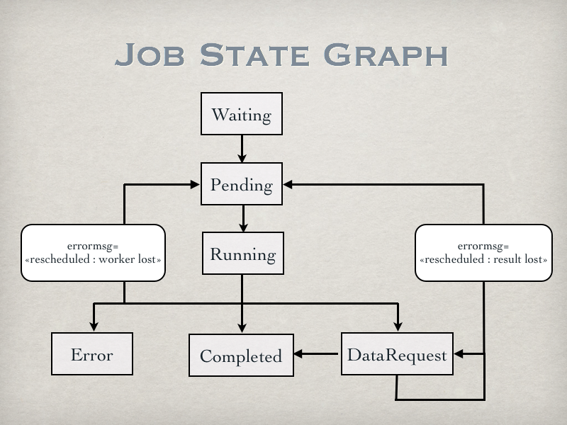
Illustration 3: XtremWeb-HEP job state graph

Contacts

If you need help contact XWHEP team: xtremweb (at) lal.in2p3.fr

The XWHEP website: http://www.xtremweb-hep.org

You can find RPM and Mac OS X packages at this address:
http://www.xtremweb-hep.org/spip.php?article52

Membership request to VO:
https://grid12.lal.in2p3.fr:8443/voms/vo.lal.in2p3.fr/Siblings.do

Third party libraries

jLite library:
http://code.google.com/p/jlite

Bouncy Castle library:
http://www.bouncycastle.org/

Jetty library:
http://jetty.codehaus.org/jetty/

Index
Index lexical
bouncycastle 6, 47
HOME 4
JAVA_HOME 7, 12, 13, 14
Jetty 47
jLite 47
logging and bookkeeping 18
match making 43, 44
uripassthrough 45
XWHEP_HOME 4
XWHEP_VERSION 4, 13

https://trac.lal.in2p3.fr/DGHEP
http://www.bouncycastle.org/
http://ant.apache.org/
http://jetty.codehaus.org/jetty/
http://jetty.codehaus.org/jetty/
http://www.oracle.com/technetwork/java/index.html
http://www.sonarsource.org
http://junit.sourceforge.net/

